**The Development of the   
*Early Learning Community Action Guide***

The *Early Learning Community Action Guide* from the Center for the Study of Social Policy (CSSP) and the National League of Cities (NLC) was developed over three years of work with early childhood leaders from communities with well-established early childhood systems. CSSP and NLC sought and received input from parents, national experts and other key stakeholders along the way.

With generous funding from the Bezos Family Foundation, NLC and CSSP launched their Early Learning Nation project in 2015. CSSP worked with its existing Early Childhood Learning and Innovation Network for Communities (EC-LINC) while NLC recruited a cohort of cities to work together on City Leadership for an Early Learning Nation.

In late 2015, CSSP convened a “learning lab” with participants from seven EC-LINC member communities focused on what it means to be an early learning community. Through monthly phone meetings over the course of seven months, participants articulated a set of four “building blocks” of early learning communities as well as the infrastructure required to support those building blocks. Members provided feedback on early drafts of the paper that would describe those building blocks and identified examples from their own communities to help illustrate what each building block looked like in practice. The resulting paper, [*Early Learning Communities: Building Blocks for Success*](http://www.cssp.org/media-center/blog/text/Building-Blocks-for-Success.pdf), was released in the summer of 2016.

## **Building on Previous Work**

Both CSSP and NLC have long   
histories in the field of early   
childhood. Each organization   
comes to this work with foundational frame-works that are in use across the country and guide our approach. CSSP’s [***Strengthening Families Protective Factors Framework***](http://www.strengtheningfamilies.net/) is a research-informed approach to engaging families, programs and communities in building five key protective factors to improve outcomes for young children and their families. NLC’s [***Elements of Educational Alignment***](http://www.nlc.org/find-city-solutions/institute-for-youth-education-and-families/early-childhood/educational-alignment-for-young-children)help cities consider how to support a well-aligned educational system that includes streamlined communication and coordinated services that address the full range of academic, behavioral, health and family issues. Both of these frameworks, and NLC and CSSP’s experiences supporting their implementation, informed the development of the *Early Learning Community Action Guide*.



In the fall of 2016, CSSP and NLC sought additional feedback on the building blocks structure, from communities in the networks who had begun putting it to use, and from colleagues with expertise in neighborhood-level work. Minor revisions were made to the building blocks paper, with the most significant changes in the section about “neighborhoods where families can thrive.”

Development of the *Early Learning Community Action Guide*, and its accompanying Progress Rating Tool, began in late 2016. CSSP and NLC staff built out the “targets” of each building block with descriptive statements of what this would look like in a community that is just getting started, a 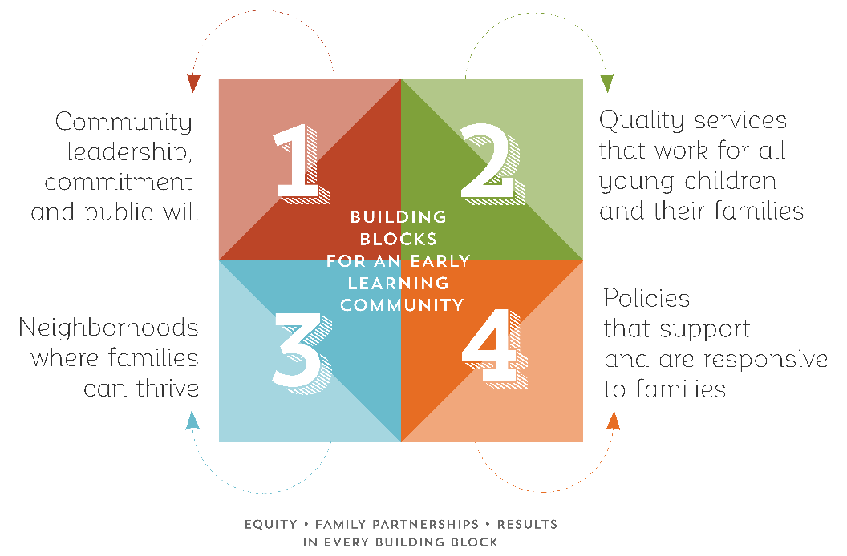community that is making progress and a community that has made a deep commitment to work in this area. For each of those levels, a set of action steps was developed – pulling from concrete examples communities had shared in the learning lab and in other conversations about early childhood system building, as well other observations from CSSP’s and NLC’s work in early childhood systems, policy change and neighborhood change efforts. The Progress Rating Tool was then designed to allow a community to rate its current level relative to each of the targets of the building blocks, and to identify areas to focus efforts.

In early 2017, an initial draft of the *Early Learning Community Action Guide* was shared with colleagues at seven national partner organizations, who provided comments on what was already written and added action steps reflecting their own experiences. A revised draft reflecting those changes was shared with volunteers from 11 communities, who again gave feedback on the extant content and suggested additions.

Our partners in four communities – First Steps Kent County (MI); Housing Partnership, Inc. and the Children’s Services Council of Palm Beach County (FL); the Pittsburgh Association for the Education of Young Children (PA); and United Inner City Services of Kansas City (MO) – hosted parent focus groups in May 2017, eliciting feedback on the parent engagement content of the *Early Learning Community Action Guide* in particular. Across these locations, 24 parents shared their perspectives, their reactions to the draft and their suggestions for additional action steps for decision-makers to better engage parents and other family members in the critical work of becoming an Early Learning Community.

With all of that feedback incorporated, the *Early Learning Community Action Guide* was designed for distribution and shared with partner communities in summer of 2017. Twelve communities volunteered to pilot using the *Action Guide* and its companion Progress Rating Tool. A wide range of communities were involved in the pilot, from rural to urban and from across the country. Most importantly, the pilot group included some communities that were just beginning to organize key stakeholders to focus on early childhood, and others that already had strong early childhood systems but were looking for new tools to help them broaden their focus or be more accountable to shared outcomes.

The pilot communities’ experiences putting the *Early Learning Community Action Guide* into practice informed final revisions to the building blocks framework and the content of the *Action Guide*, as well as the development of additional guidance for other communities. In 2018, the *Early Learning Community Action Guide* and Progress Rating Tool were finalized. Work is underway to share the contents of the *Action Guide* and the Progress Rating Tool in an interactive, online format to engage additional communities in becoming Early Learning Communities.

## **Timeline**

**Foundational Work**

CSSP’s Strengthening Families initiative began in 2001

NLC released the Elements of Educational Alignment in 2012

**2014**

Early Childhood Learning and Innovation Network for Communities (EC-LINC)   
convened by CSSP and local partners

**2015**

CSSP and NLC receive Early Learning Nation funding from the Bezos Family Foundation

NLC recruits seven cities to its City Leadership for an Early Learning Nation (ELN) cohort

CSSP launches an EC-LINC Learning Lab focused on what it takes to be an Early Learning Community. Representatives from seven communities take part in seven conference calls and develop the building blocks of early learning communities

**2016**

CSSP releases *Early Learning Communities: Building Blocks for Success*, informed by the Learning Lab and reviewed by representatives of seven EC-LINC communities

CSSP and NLC begin drafting the *Early Learning Community Action Guide* and Progress Rating Tool, articulating levels and concrete actions for each of the building blocks

**2017**

Early drafts of the *Early Learning Community Action Guide* are reviewed by seven national partner organizations, 11 representatives from EC-LINC and the NLC cohort and content experts at CSSP and NLC

Parent focus groups are held in four cities to give feedback on the parent engagement content of the ELC Action Guide, with 24 parents participating

13 communities volunteer to pilot the *Early Learning Community Action Guide* and Progress Rating Tool, applying it to new or ongoing early childhood system-building work, and provide feedback on the content and additional materials to inform other communities’ use of the tools

**2018**

The *Early Learning Community Action Guide* and Progress Rating Tool are revised and finalized based on the feedback from piloting communities. Additional materials and graphics are developed to support the dissemination of the materials.

Work is underway to develop an interactive, online treatment of the *Early Learning Community Action Guide* and Progress Rating Tool.