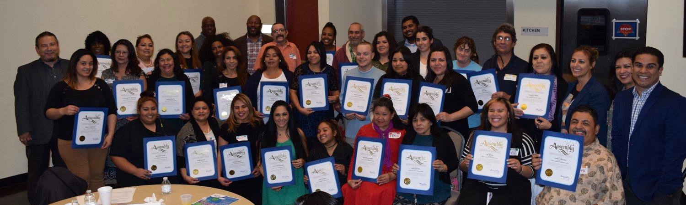

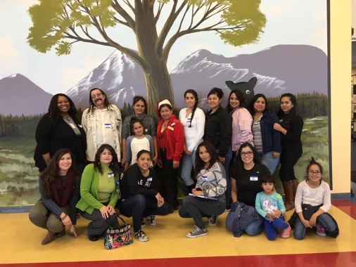
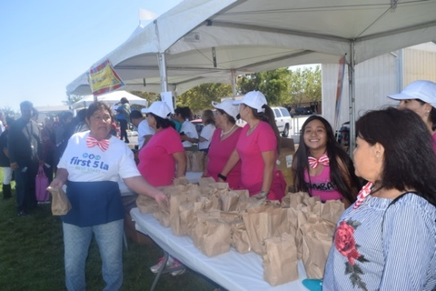
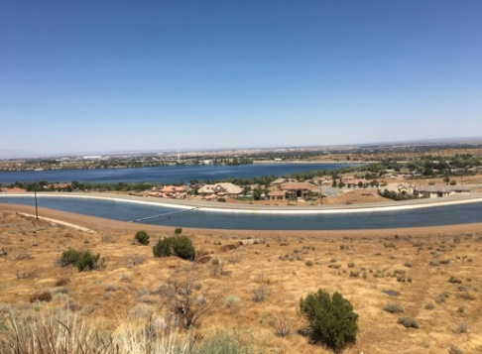

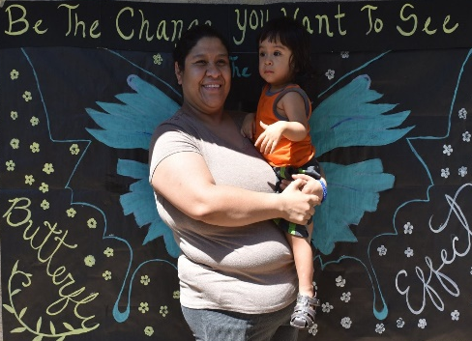

The Antelope Valley Core Support Team—an Exemplar Among Best Start Community Partnership Support Teams

October 2018

Written by:
Audrey Jordan, Senior Consultant and Lead Coach for CSSP
With contributions from:
Araceli Simeon, Capacity Building Consultant for CSSP
Miguel Perla, Capacity Building Consultant for CSSP
Joaquin Macias, Senior Program Officer for First 5 LA
The Antelope Valley Core Support Team – an Exemplar Among Best Start Community Partnership Support Teams

The Antelope Valley Community Partnership is one of fourteen partnerships across greater Los Angeles within the Best Start Initiative. The Best Start Initiative is a First 5 LA funded, place-based change initiative that “brings together parents and caregivers, residents, organizations, businesses, government institutions and other stakeholders to collectively build a vision and develop strategies to create the best possible community for young children and their families. They collaborate to improve a community’s policies, resources and services to better support residents, and create that place where families can thrive. Best Start then provides the skills-building and leadership training to help them achieve their goals and ensure that children enter kindergarten ready to succeed in school and in life. This is done through groups we call Community Partnerships, which meet on a regular basis.” (from the Best Start initiative web page: http://www.first5la.org/index.php?r=site/tag&id=576).

The Best Start community partnerships were supported by teams made up of First 5 LA staff and consultants who provided coordinated resources, training, guidance and opportunities so that the partnerships could meet and work together in the fourteen localities. The support team for the Antelope Valley communities stood-out among the others and proved itself to be a model team.

What makes for an effective and successful collaborative team that supports Best Start community partnerships? A conversation with the core support team members for the two Antelope Valley (AV) communities of Lancaster and Palmdale, Araceli Simeon and Miguel Perla (capacity builders who shared responsibilities across the two sites), and the then AV program officer from First 5 LA, Joaquin Macias, revealed key ingredients in the “secret sauce” of their positive and fruitful partnership. They were asked (and their responses follow):
- What is the essence of your partnership? And what drives it – why did this work?
- How did you work together?
- What contributes to your ability to be true partners with each other, with the community partnerships, with other stakeholders?
- What contributed most to your efficiency as a team?
- What contributed most to your effectiveness as a team?
- What are some lessons learned and tips you would pass on to other teams interested in supporting resident groups like Best Start partnerships?

What is your partnership, and what drives it?

We took a team approach. Even though we all had prescribed roles, we didn’t let that circumscribe our functions. We did our roles but rolled-up our sleeves and pitched-in when needed. We had more expansive roles and modeled that culture for all others we were working with. In the end, we earned our spot as leaders, not by a title but by earning credibility and respect.
In addition, we all came to this work from a social justice, racial justice analysis. It is more than a job – it is commitment to service. It is an opportunity to help make change happen for communities that have been struggling for many years in the AV. We knew that some people had to move out to AV because they couldn’t afford to live in the City of LA any more.

There were a few other important things we recognized when we formed our team: a) we are all people of color (POCs), and we carry a certain sense of obligation to these communities; that’s important, and we wanted to make sure that we leaned into the power of this cultural congruence; and b) there was a history of broken relationships with staff and consultants in the AV, with lots of disappointments, frustrations, and distrust. All of us on the core support team (the program officer and capacity builders) came into it ready to tell the truth, apologize for the past but to say “I am committed – let’s move forward together.” You do your part, I/we will do ours - you have our word. I think people appreciated this candor, commitment and respect.

It’s also about who we were when we arrived to this work. There is a basic understanding that I don’t know everything that needs to be known for the team to do all it needs to do, so I have to depend on others on the team and the residents. The three of us realized we needed to make space for people to their jobs – and we can add value, that is what to do. Joaquin Macias, the First 5 LA program officer went on to say “As the funder rep, I believe this is the tone that needs to be set. Plain and simple. Also, I made sure we communicated frequently to make sure we are on the same page about who’s doing what, what work each person has to get done, what is our shared work, what do folk need from me to get it all done. You help me do my job, I am helping you do yours. People saw that we were operating this way, saw that we worked hard, and they followed suit.” Some on the larger team didn’t trust at first, but over time they did.

How did you work together?

It is important to note that we were the only capacity building team that started-out by dividing responsibilities between two people for the two AV communities – we requested we split the responsibilities this way. The AV communities are so remote – so we wanted to address head-on the challenge of just getting out there regularly. We got to know how each other works, and we learned we have very complementary styles. Once we knew this, we trusted each other to do our part in each community and we stayed in our lanes.

We got to know the communities and their different identities and histories, and then we went the extra mile – by participating in community events not just for Best Start events or when it is work, but to be present and get to know the community and support them. To appreciate what they know and care about. We have a compassionate mindset, a solidarity mindset, we know the community has been through lots of trauma. And we bring a trauma-informed lens, with emphasis upon racial equity and restorative justice.

We didn’t necessarily know we had all these things going for us – the cultural congruence, the complementarity of styles, the almost natural inclination to work in teams – we were doing it before all these terms became so popular – we just looked at it like being in these remote communities and working smart together for/with these marginalized communities as an opportunity to get resources where they are needed and appreciated – a way we can make an impact in the communities. So, because we knew the need was so great but the desire to work together for change was also great – our approach was as long as it is not illegal, unethical, we’re going to push for it. Even when confronted with all the bureaucracy – we’re not saying “well we can’t do it,” we’re saying, “if that’s what we need to do, I don’t know how but I am going to find out.” Even when we get “no,” we ask why not, and then figure out how to address the concerns. We never just took no for an answer. We pushed – and you don’t have to be aggressive. But you model getting things done, looking for solutions.

What contributes to your ability to be true partners with each other, with the community partnerships, with other stakeholders?

We have all learned and embraced the importance of relationship-building. Genuine relationship-building – where you appreciate the histories, strengths and challenges that everyone brings to the table. And you learn how to value all of it, and work through disagreements, to agreements and consensus. Where you spend the time on process – which is important – but you get to action, you produce results and you build on success. First there are lots of informal meetings. But then, once the work that is needed becomes clearer we moved from informal meeting and we formalized them. The program officer (Joaquin) used his “authority” to ensure that other contractors who may have been reluctant to attend periodic planning meetings to do so. He had the clout to make sure everyone knew they were expected to attend these important meetings to get clear about and agree on the work that needed to get done, and who was doing what.

We helped community members see their strengths and contributions and we built from there. This made room for each of them to plug in, to share their talents through committees, events, leadership, social media etc.

We also worked hard to lift-up for the organizational partners- a power dynamic that many seemed not to understand at times in the meetings. They didn’t seem to recognize the need to make space and take time for the residents to understand and participate fully in planning meetings. We insisted on holding space for more equitable discussion and decision-making. And we as capacity builders did capacity-building with the residents so that they understood their by-laws and meeting agreements to balance out the voices and the power. It also helped that while all the other contractors were coming in and out of the partnership over the years, we were the constant.

What are some of the challenges you faced, and how did you deal with them?

It wasn’t easy to get on the same page with all the contractors and organizations. They had their own directions from their management and some were very reluctant to step outside of those directives. Our program officer listened to their concerns, listened to what they needed to get done, listened to their interests and helped them do what they needed to do while also helping them see how being team members would help us all get things done for and with the community members.

A big challenge was that community members were so distrustful given their past experiences with all the organizations involved, including First 5 LA, so we had to work hard to engage them beyond just showing up to get free meals, or as they had become accustomed to doing, just coming to get what Best Start had to give to them. We supported conversations where community members built agreement on their collective goals, not just First 5 LA’s, and had to essentially prove that as long as they wanted to do the work and were willing to work with us, we were going to work hard for them and eventually we would see changes happening in the community. They saw the opportunity, and they accepted the invitation to reset in the AV. Then we established a track record where we were responsive and we did what we said we were going to do. From the trivial to the more important. Tablecloths? Check. Getting meals on time, reliably? Check. Responding to difficult team dynamics? Yes- we dealt with conflicts, power-dynamics. We met and strategized and acted. We did work behind the scenes, we brought observations and intentions to the community, transparently – we worked out plans with them. Set goals, developed strategies, activities, showed progress and talked candidly when things came up and we weren’t able to move forward as planned.

We had to deal with a few savvy residents who had learned some bad habits of taking advantage and pushing through what they wanted for their own self-interest. We managed this dynamic for a while and as the other residents built their skills and were able to hold each other accountable, those self-interested residents either left or figured out how to get on the same page with the others. Yes – we have a few good examples of how you engage some residents who are natural entrepreneurs (aka hustlers) to redirect their efforts toward the group agenda. The good news is that in most cases, they bought-in and became strong leaders on the team.

We had to pay attention to bringing in more diversity – the black folk had fallen away from the table in Palmdale (where there are some serious black-brown tensions); whereas in Lancaster, we had to infuse new blood, expect participants to show up and work for the change they wanted to see in their communities as opposed to looking for organizations to make decisions for them that they would ultimately be unhappy with, anyway. In both places we had to engage the ROCs/NACs to help bring in more people – which was not something they were necessarily excited about doing at first. We got new people in who were highly skilled, and this shook things up. Disrupted the complacency that had previously set in, and they wrestled with it and worked it out. There is still lots of work to do in both places, but we saw and worked on two very different strategies to broaden the table and we asked – “What can we do to influence the change that was needed?”

What contributed most to your efficiency as a team?

What I learned from doing campaign work, I brought to this work: you have to meet regularly, use the big walls, write stuff down, have timelines, hold people accountable for what they said they would do. Seeing this work as campaign work was very helpful for me. What we did really was a lot of organizing work – with the other contractors and with the residents. They had to adjust, and in many cases, they did. It was very important that this approach was shared by our program officer, who brought the imprimatur needed for everyone to choose to get on board.

As an example of how this worked out: One of the contractors was adamant that they weren’t recruiters for the partnerships. They saw themselves as information sharers with the community groups, not weavers connecting the community groups to the Best Start work. So, we started with them as information sharers and asked them to make sure some of the information they were sharing was the flyers for the Best Start Community Partnership Meetings, and making sure prospective participants knew that they could get transportation and meals and childcare for attending. Eventually, people from the neighborhood groups started to check us out and the contractor staff started encouraging them to come. We started having support team meetings of all contractors where each of us was sharing what we were each doing and used the partnership space as a place to understand how to support each other’s work. Eventually it became a space where we could engage with the community members and where we could all be on the same page and coordinate, and everybody gets their work done and provides opportunities for the AV communities (not just a focus for an individual organization’s interests). When contractors saw us supporting their activities, they would support Best Start activities.

We also focused on getting clear about people’s roles. Things they were doing that were in their job responsibilities, and things where people were going above and beyond to support other organizations and the community at large. We made sure everyone got clear on roles, responsibilities, and expectations. When people saw the capacity builders and program officer showing-up at community events, taking pictures, bringing things they were paying for out of their own pocket at times – people came to appreciate that we really cared about the community and not just our own agendas. Again, setting an example of true leadership and partnership.

It helped tremendously that residents were able to take on more leadership roles once we provided trainings to help to get them there. As capacity-builders this was our main goal throughout the years – build residents’ capacities to run their own meetings, set their own results-focused agendas and then know how to hold themselves and other stakeholders accountable to achieving shared goals. In providing these trainings, we got to know a smaller, core group of people very well. Seeing the residents step up and excel made organizational partners step-up, too.

And of course, communication and coordination and follow-through! We had lots of informal communications. We shared our phone numbers and people could/would call us and talk about their concerns. They shared phone numbers with each other – something they hadn’t done before. And then we had regularly scheduled, formal meetings: weekly, quarterly. Retreats/Strategy sessions every six months. Having these regular times to check-in and reflect and assess what was going well and where we might need to change course helped us stay on track.
Finally, the program officer helped to encourage the program support staff (PSS) feel valued in ways they hadn’t felt before. For years there had been many times when the PSS had dropped the ball on a meeting, food, transportation, venue, etc. These kinds of missteps felt (and were) very disrespectful to the community members! Joaquin helped to underscore how important that aspect was to the work and really hold these staff accountable. Once a new PSS came on-board, she helped to really solidify the effectiveness of our team. She was very organized, thorough, patient, and open-minded. She set up systems where community members felt the appreciated and that greatly helped the AV reach success.

What contributed most to your effectiveness as a team?

Initially, we really pushed through the Learning by Doing process where we identified priority goals and key strategies the community members in each city (i.e. Lancaster and Palmdale) wanted to anchor their partnerships. In Palmdale, we really got behind the Parent Navigators as a key strategy and that was probably a key decision made by the partnerships. Why? Because working through that strategy made us realize we had to negotiate an innovative strategy to get some parent navigators hired to cover the region. Vision y Compromiso became the organization which provided base training for the Parent Navigators, and this really cemented their outreach strategy as they later became the Building Stronger Families grantee. So, that one consensus decision addressed the needed to connect people who lived remotely in large geographic areas, provided jobs for residents, some of whom were partnership members, and strengthened the support of one of the most important support organizations in the AV.

And then we as support team members were able to bring our own strengths to the work -Araceli brought her advocacy training, Miguel brought his outreach-engagement skills; and Joaquin was able to advocate for Parent Navigators as a necessary strategy inside of First 5 LA. It was a triangulation of all three pieces.

Getting stuff done – experiencing success. We did THAT. Resource Guides – we couldn’t do that. But AV needed this kind of information resource. So, we found out what else we would call it, and we got it pushed through. Along the way we also really helped Antelope Valley Partners for Health (the Building Stronger Families grantee for the AV) learn how to do community engagement work – they are the largest service organization in the area – and an umbrella organization with lots of different programs and partnerships with organizations/non-profits. The community appreciates some of the organizations under that umbrella, and others not as much as they work with families at various levels of engagement; some only outreach to families, others consult, involve or collaborate, but none is yet at a level where they are sharing leadership the way Best Start was intended. But they were a good partner, know the community and learned to co-design and collaborate with the community. We are hopeful that at some point all the organizations under the umbrella will authentically engage the community and for the community to be appreciative of the organizations’ work. Being a part of the Best Start Partnership and witnessing its successes, no doubt contributes to AVPH’s commitment to supporting the community partnerships. Along with the fact that lead staff there have worked successfully with the AV school districts.
Very simply and in summary, we set goals, we shared leadership responsibilities, we held ourselves and community accountable, we celebrated successes along the way, and we learned from our failures. And then responded to the learning. We told each other when we messed-up. But we said publicly – WE messed-up. We all took responsibility when there were mistakes, and we shared credit when we had successes.

As an example of a mistake – there was a instance when for the sake of expediency, a capacity-builder choose to circumvent the Guidance Body and made a decision. Of course, this caused some controversy and resulted in conflict. We stepped-up, pointed out the mistake in not following the partnership’s own rules, and agreed on the process for the next time a decision.

As our time as capacity builders was winding down, we learned that it was important to let them make their own mistakes and learn to lead. Even when we wanted to step-in and do it, we didn’t (even when they asked us to just do it) – we said “we’re only here to do what you tell me we need to do, and to support you doing what you absolutely can do.” They would work it out, they grew, and they did it.

There were times when we’d do things together – Lancaster & Palmdale as the AV communities – but still recognized they were different communities with different needs, different interests. We encouraged both communities to have their own identity. Each now has their way of doing things, can call each other out, refer to their plans and their by-laws. They are practiced and take ownership – sometimes they still want us to do for them, but they know we won’t and definitely can’t expect this of the organizations who have now come in to provide support to them (i.e., the RNG & LNC). This is exactly what we hoped would be where they would wind up.

Successes were built from failures, bad situations. People now understand that failures are learning opportunities.

We achieved our most desired outcomes - Increased memberships; community partnerships that are run by residents; and partnerships that are diversified and more representative of their communities. These are successes we and the communities are proud of!

Top of the List lessons learned:

- Pay lots of attention to trust and team-building. Like we did with each other. It is important to take the time to build trust among team members. It matters so much! And spend more time and attention with the partnerships on team-building. It is so important. Maybe wait to do sponsorships until you do some work on trust-building.

- You have to work through relationship tensions, not try to side-step or get around them. If conflict mediation is necessary – invest the time in it sooner rather than later.

- Take the time to reflect and plan and re-adjust. It is hard when there is a constant influx of new people – which there should be. But you have to figure out a way to bring in new people and orient them and do the reflection and readjustment to plans. We did it every six months – it needs to be done at least annually.

- Invest in better ways to orient new people, and help them understand what they are walking into, what are the opportunities and achievements of the partnership. But also realize orientation goes two-ways – orient the existing group to the new people and what they bring, what they are looking for from their participation. Be clear about what it means to be a member of the partnership – what is expected.

- We would have benefitted from more knowledge about race relations, multi-racial coalition-building. We were lucky that our program officer is both Black and Latino, so he could be a bridge to both groups. In a way, though, this luck could have masked some of the work that has to be done.

- There was so much infrastructure, identity and capacity building of the group that had to be done that we didn’t spend as much time as needed the policy and systems change work. It is next-level work that they know needs to happen, but these will require a lot of capacity-building and work to do to have real power and impact in the AV.

Tips/Advice for Teams who support resident-centered, place-based community-building work:

- Account for turn-over and churning of people in and out of the partnership space.
- Be mindful of trauma and its effects on people in these communities.
- Spend time on team-building, trust-building! And learning each other’s strengths.
- Understand the life cycle of community work and don’t sweat the small stuff!
- Get out of the way and let the partnership members lead/work it out, even if it isn’t perfect, so they can learn to do for themselves. Don’t rescue.
- Often times, funders have their deadlines and exigencies, which challenge the plans that activities of community partnerships. Much of the work of the support team is protecting the pace of community-driven processes; and sometimes stopping to focus on conflict resolution & team-building or some other important issue that the partnership has to confront.

