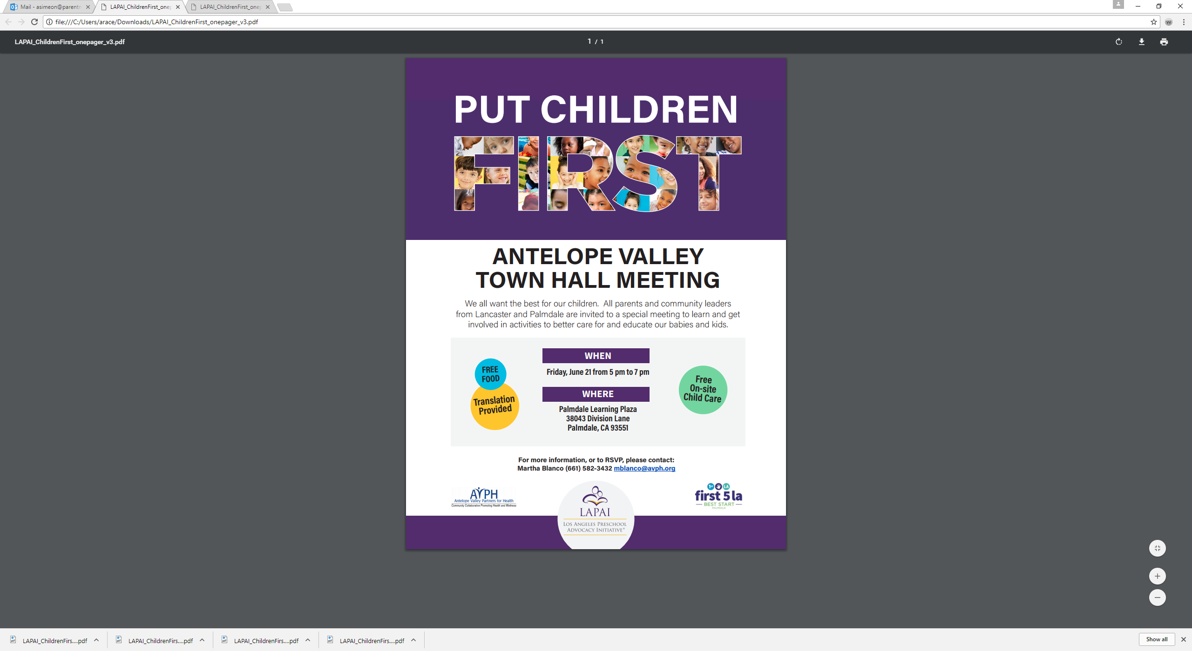

**AGENDA**

**Friday, July 21, 2017**

**5:00 – 7:00 pm**

1. **Welcome |** Bienvenida
2. **Icebreaker |** Rompehielo
3. **Early Childhood Education Landscape |** Panorama de la educación temprana

**Guest |** Invitado: **Roberto Viramontes**,Senior Policy Advisor

**Learning Policy Institute**

1. **Antelope Valley Data |** Datos del Valle del Antílope

**Guest |** Invitada: **Michele P. Sartell**, Child Care Planning Coordinator

**County of Los Angeles Office for**

**the Advancement of Early Care and Education**

1. **Next Steps |** Próximos pasos
2. **Closing |** Cierre