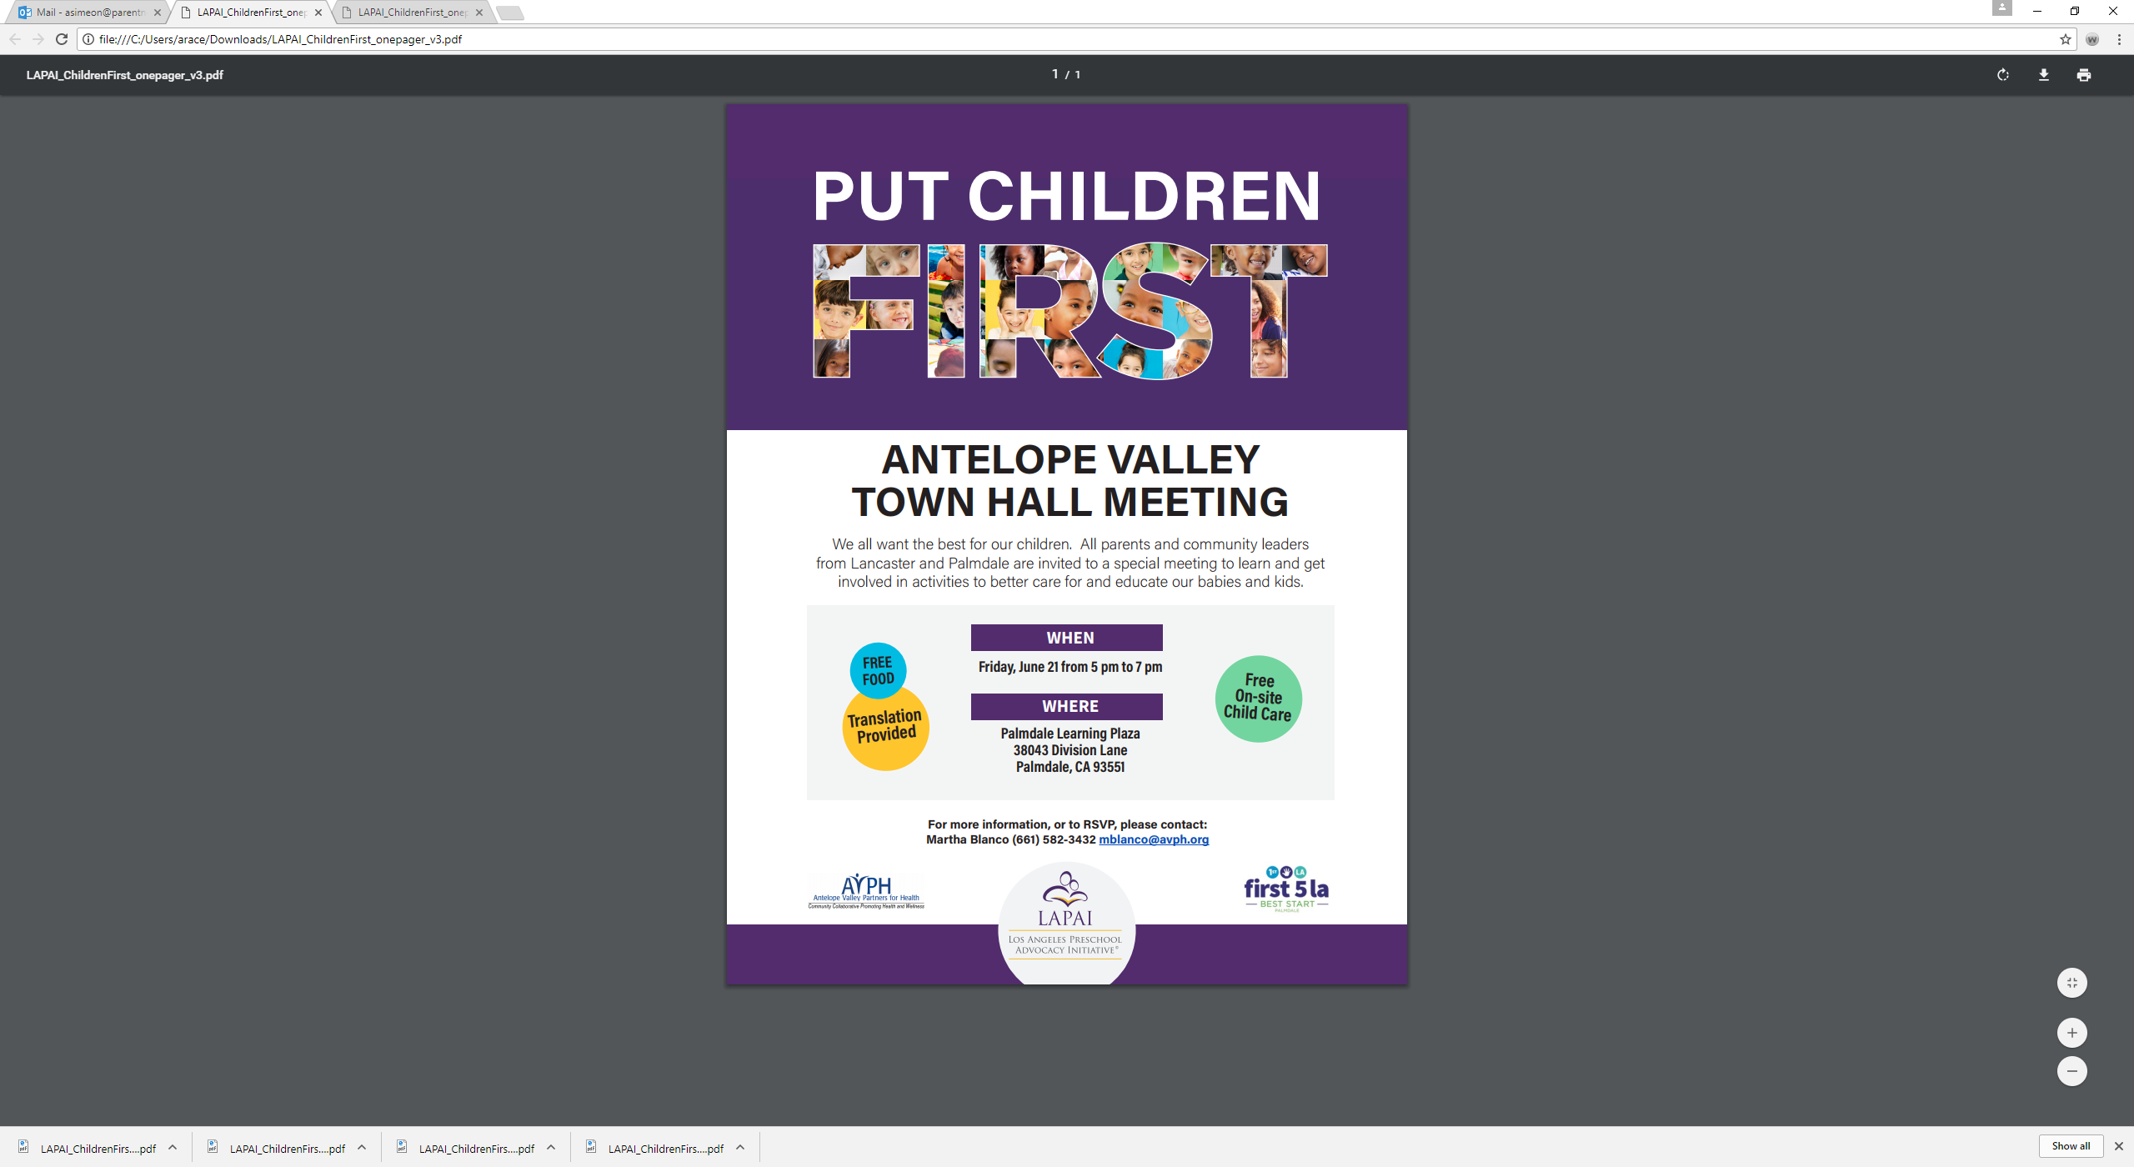

# Statistics

* **170** persons attended including parents, community members, teachers and childcare providers
* **Areas represented:** Palmdale, Lancaster, Littlerock, and Lake LA
* **Gender:** 158 Females: 12 Males
* **Race/Ethnicity:** Latinos, African Americans, Whites
* **Languages Spoken:** English, Spanish, American Sign Language

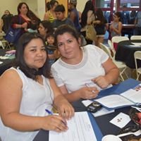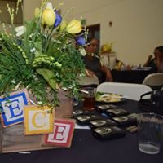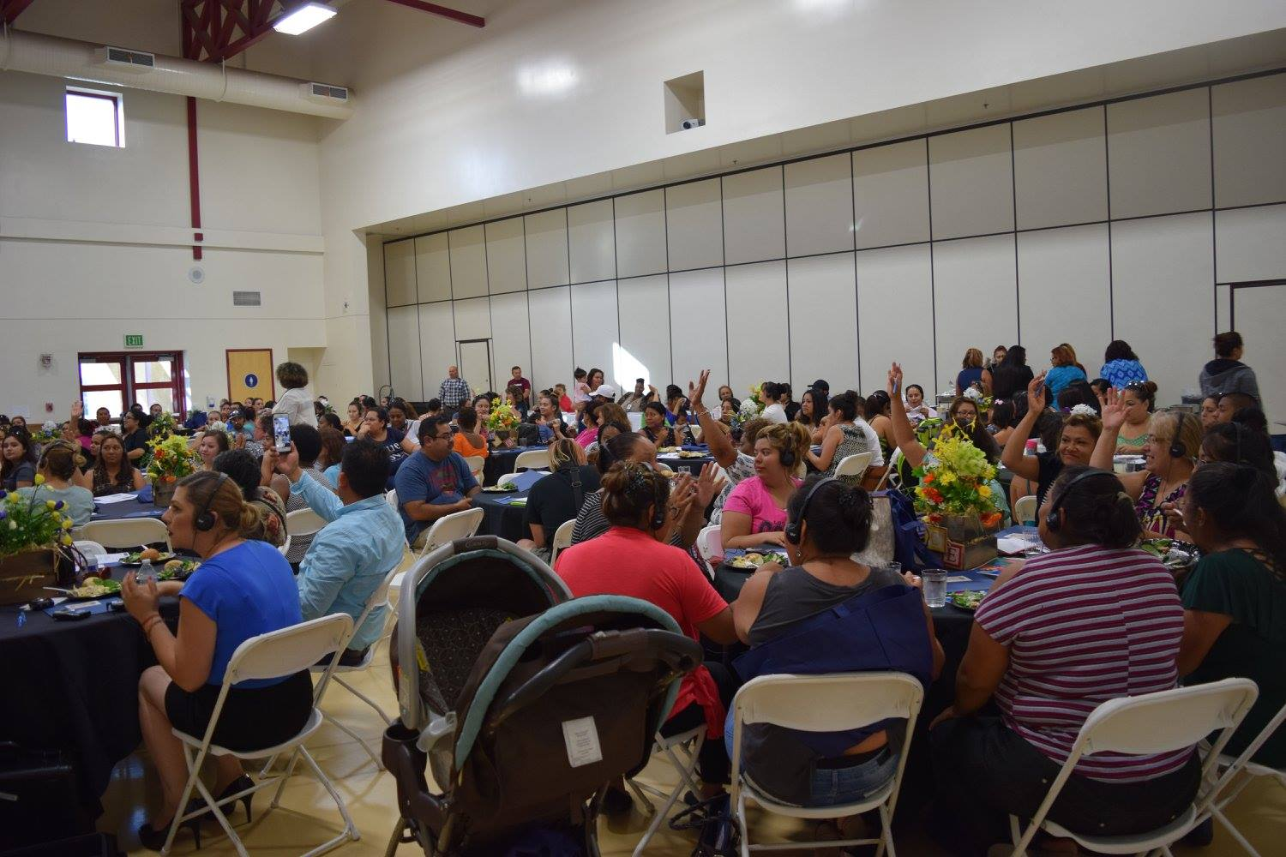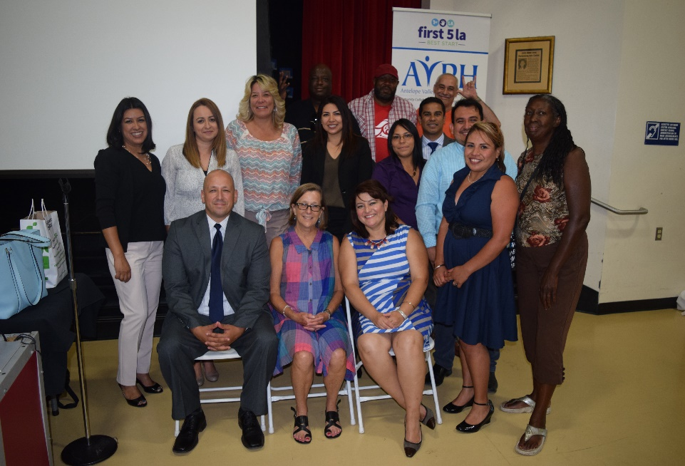

NEXT STEPS:

1. Develop advocacy plan
2. Plan Forum II

# outcomes

## Learned about ECE system’s complexity and funding streams. Findings:

## **Parents are not fully aware of all their options. If they do not qualify for one program, they may not know to ask about others.**

## Increased knowledge on the state of child care services in LA County, AV. Findings:

## **Families in the region need more access to both affordable child care and preschool services.**

1. **Lancaster families report accessing preschool services in Palmdale USD, as their district does not offer programs.**

## Promoted ways to get involved through Best Start, CCRC’s advocacy training, CHIRLA’s voter registration drive

## Dialogue highlighted current family needs in the AV: They want more services and are ready for action.

**Best Start Palmdale**