- NAME of the resource / tool | BSL Speech Outline for Guidance Body Nominees
- WHAT is the purpose of the resource / tool? | This outline is meant to serve as a speech preparation guide for BSL Guidance Body nominees who will each have an opportunity to address the community partnership on election day.
- WHO developed the resource / tool? (If it was adapted from an existing document, please include a citation for the original source.) | This document was developed by the Best Start Lancaster capacity building team.
- HOW should the resource / tool be used?  - What circumstances are ideal/appropriate?  - By whom and when?  - Is a particular skill set or special preparation needed? | - This tool is distributed to Guidance Body nominees as part of election day preparation.  - Group facilitators or leaders walk nominees through the guidance provided and invite questions for clarification, as needed.  - Nominees are also encouraged to practice and refine their speeches with the help of peers/family/friends/  - It is also important to make coaching for public speaking available for those who would like added support or assistance with preparation.
- WHY is this resource being recommended? (What makes is especially effective or useful for community-based work?) | The use of this outline will help to ensure that Guidance Body nominees are well prepared, on topic and able to adhere to time limits during election proceedings.

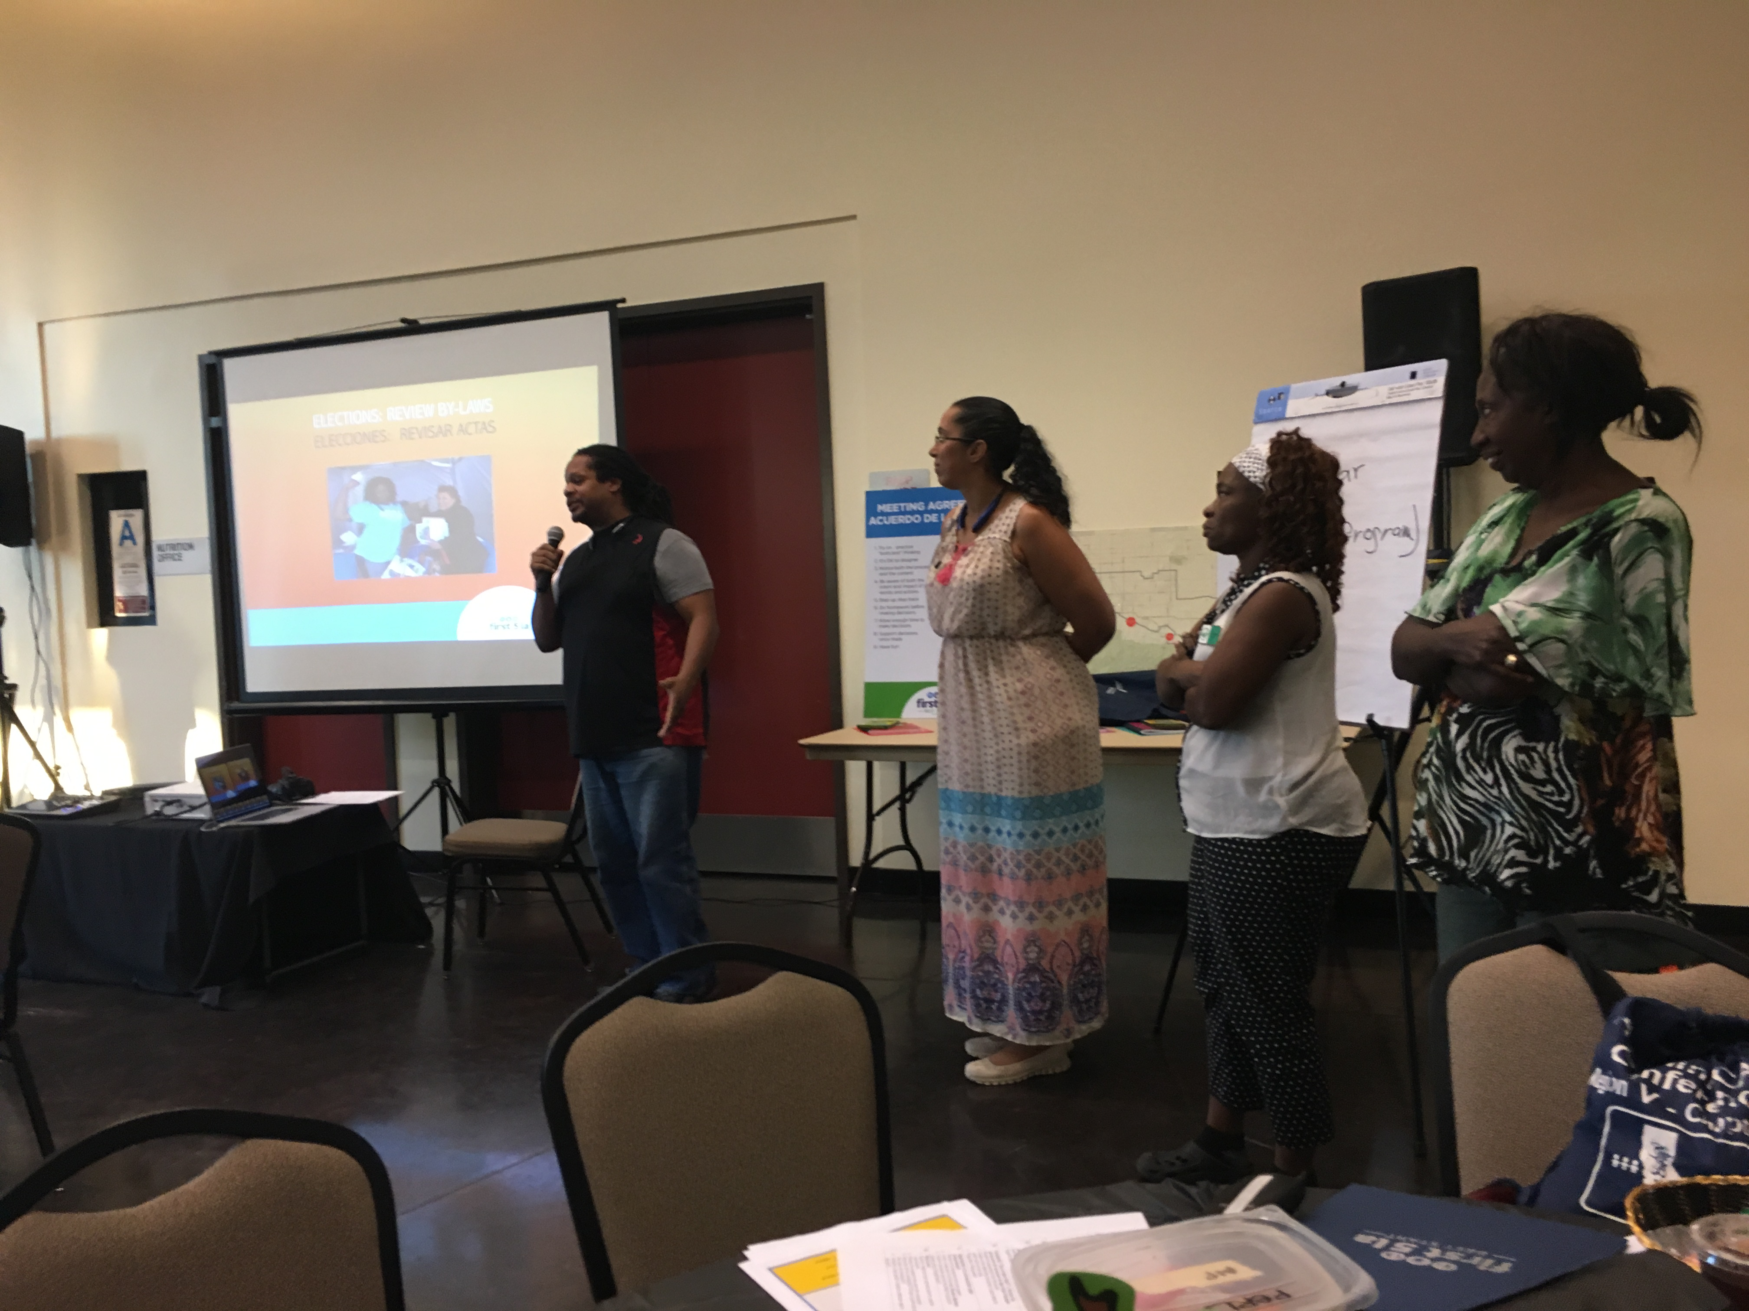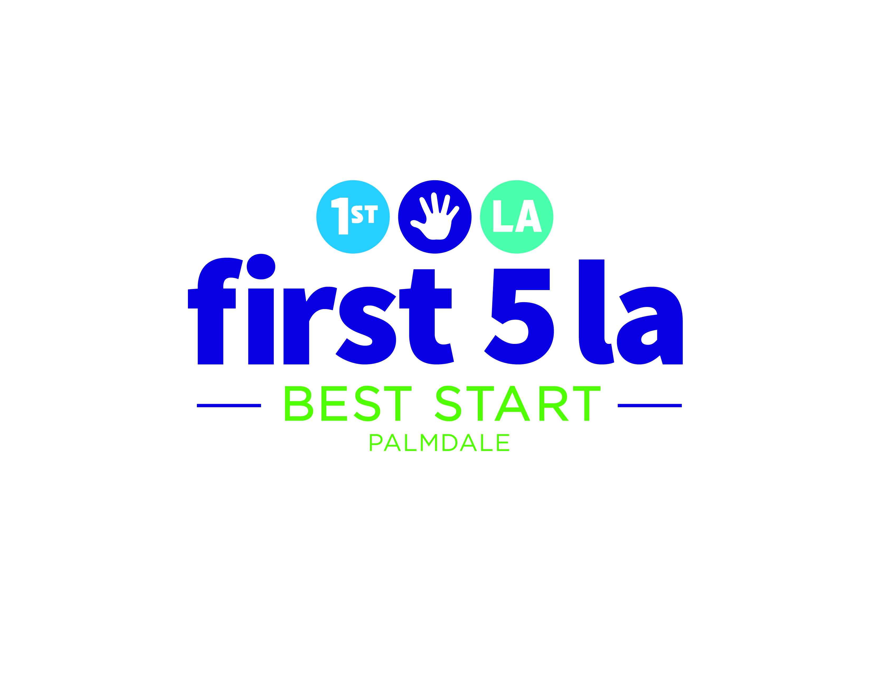

Guide for Two Minute Speech Guidance Body Nominees
Thank you for considering being part of the 2017 Guidance Body. We appreciate your enthusiasm to help lead the Best Start Community Partnership over the next year. In order for partnership members to make the best informed decision about who they should vote for in the election on January 24th, we would like to invite all nominees to give a two-minute speech introducing themselves and sharing why they would like to be part of the Guidance Body.
Suggested points you may want to include:
- Introduce yourself and where you live and/or work
- Tell us about how long you have lived within Best Start Palmdale community
- Why would you like to be part of the Guidance Body?
- What kind of experience do you have that will help you to be an effective member of the Guidance Body?
- You may even want to share a story that demonstrates a little bit about who you are and your leadership abilities/qualities
- If you have already served as a Guidance Body member or have volunteered with the Community Partnership in the past, you may want to share your experience.
Sample:
Hello everyone- my name is Ana and I am a grandmother. I have lived in Palmdale since 1993 when I moved here with my husband from Los Angeles. I grew up in Costa Rica, where I studied to be a teacher. Since I came to this country worked at a bank, at various non-profits and later on I retired from the US Postal Service. I also raised my two sons who are now adults with their own families.
I would like to be part of the Guidance Body because I believe I will do a good job at helping to bring in new people to the Partnership and I am good at bringing people together to work for the common good. I previously office manager for a women’s empowerment organization called “Power” where we worked to train participants for occupations and placement in jobs.
Please vote for me to be part of the 2017 Guidance Body for the Best Start Palmdale Community Partnership. Thank you.

