PST RESOURCE OVERVIEW

- NAME of the resource / tool | BestStart_SEMEM_Bylaws
- WHAT is the purpose of the resource / tool? | This document summarizes bylaws established by Best Start South El Monte-El Monte to guide ongoing decision-making and Partnership activities.
- WHO developed the resource / tool? (If it was adapted from an existing document, please include a citation for the original source.) | These bylaws were documented by Capacity Builder Chrysta Wilson based on a series of facilitated conversations with the elected leadership group and policy recommendations that were approved by the full Partnership.
- HOW should the resource / tool be used?  - What circumstances are ideal/appropriate?  - By whom and when?  - Is a particular skill set or special preparation needed? | These sample bylaws can used as a reference developing governance policies for community-led organizations.  .
- WHY is this resource being recommended? (What makes is especially effective or useful for community-based work?) | It is a comprehensive set of bylaws that includes detailed policies that other partnerships can use a model for developing, reviewing or refining their own bylaws.

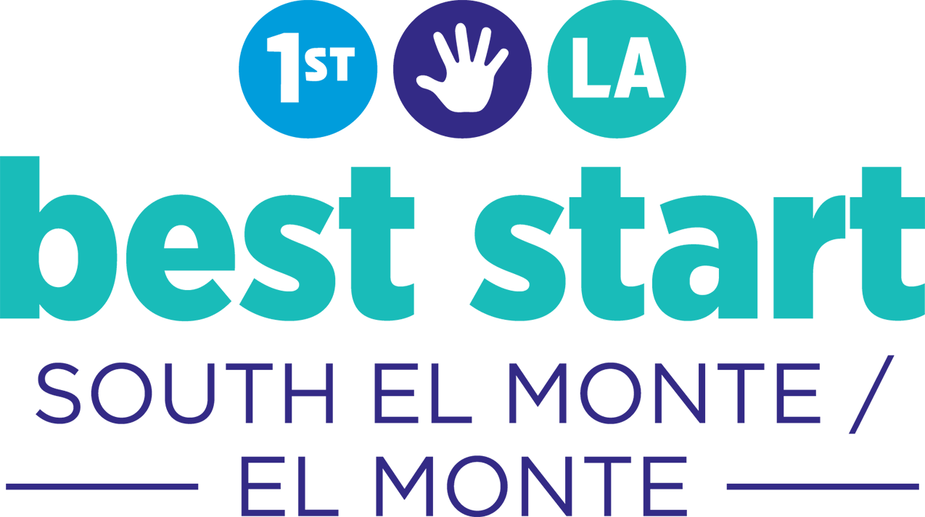

South El Monte-El Monte

Bylaws

Updated Version: June 28, 2018

Table of Contents
What are Bylaws? 3
How was this original document created? 3
Understanding this Document 3
Role of the Advisory Committee members 4
What does the Advisory Committee do? 4
What is the purpose of the AC? 4
Characteristics of an Advisory Committee Member 4
Responsibilities of the Advisory Committee 4
Advisory Committee Composition 5
Specific roles within the Advisory Committee 7
Advisory Committee Elections and Term Limits 10
Elections Schedule 10
Elections Process 10
Term Lengths and Term Limits 11
Advisory Committee Meetings 12
Meeting Dates 12
Meeting Time 12
Meeting Location 12
Advisory Committee Attendance Requirements: 12
Who can attend Advisory Committee meetings? 13
Advisory Committee’s Decision Making 14
How does the AC make decisions? 14
Advisory Committee Quorum Requirement 14
Rules Related to the Community Partnership 16
Community Partnership Official Name 16
What is the Community Partnership? 16
Partnership Responsibilities 16
Who can be a Partnership member? 16
Partnership Voting Rights 17
Requirements to be a voting member 17
Who can vote? 17
How do you lose the right to vote? 17
How do you regain the right to vote? 17
Partnership Decision Making Process 17
Partnership Committees as of 2018 18
Gaps in the SEM-EM Bylaws: Questions to Answer 20

What are Bylaws?

Bylaws are rules that help the Partnership manage itself, understand its role, and make decisions. Having clear bylaws ensures that, when an issue or question emerges related to decision-making or roles and responsibilities, the answer can be easily found.

How was this original document created?
While the South El Monte-El Monte Community Partnership had clear decision-making processes and rules from 2010-2015, there was not one document that had all the information in an easy-to-access document. This bylaws document was created in April 2015 through the review of 6 existing governance-related documents, including:

- Advisory Committee Application Form (dated 2-25-2013)
- Advisory Committee Governance Structure (dated 10-2012)
- Advisory Committee Selection and Voting Process (dated 8-2012)
- SEM-EM Advisory Committee Goals (dated 10-2012)
- Decision-Making Process from Community Plan (dated 6-2012)

The document was then reviewed and approved by the Advisory Committee (AC) in May 2015 and approved by the Partnership on July 27, 2015. The bylaws went through a final review by Chrysta Wilson, the CSSP Capacity Builder, in June 2018. This document contains all of the information and processes created by the SEM-EM Partnership related to decision-making and governance.

Understanding this Document
IDEA CLOUDS

Throughout this Bylaws document, the Capacity Builder added “idea clouds” to highlight things the Partnership should consider.
All of the content in this bylaws document has been approved by the SEM-EM Community Partnership.

Where there are questions, or where there is a need for the Advisory Committee to make new decisions, those items are located inside of thought clouds.

Role of the Advisory Committee members

What does the Advisory Committee do?
The Advisory Committee (AC) provides leadership to the Partnership to help it achieve the vision and meet the objectives of Best Start. It also serves as a liaison to the First 5 LA, Grantees, and community stakeholders.

What is the purpose of the AC?
The purpose of the Advisory Committee is to have a diverse, experienced, and committed group of local residents and service providers to oversee the efforts of Best Start South El Monte-El Monte Partnership.

The Advisory Committee will work in collaboration with the Partnership and First 5 LA to implement the community’s plans and to inspire others to become or remain involved in the Best Start effort.

Characteristics of an Advisory Committee Member
- Deeply committed to Best Start’s mission, vision, and role in the community
- Support the goals of Best Start in the development of children age 0-5 in South El Monte - El Monte
- Experience in one or more of the Best Start goals
- Open-minded, objective, and respect for diverse perspectives
- Meet the requirements of a Partnership voting member
- Live within the boundaries of Best Start South El Monte - El Monte or provide services to this area
- Contribute to the Committee’s diversity of experience, language, culture, gender and other key elements of a vibrant and diverse group
- No perceived or actual conflicts of interest

Responsibilities of the Advisory Committee
- Serve as the primary contact between the Partnership and First 5 LA
- Support overall management of the Best Start planning process, including input to Partnership meeting agendas and presenting at community meetings
- Maintain Partnership members, so the Partnership is engaged and represents well the South El Monte-El Monte communities; ensures that membership reflects the diversity of the community
- Participate in Community meetings, Advisory Committee meetings, trainings and workgroups for an estimated 5-10 hours per month through their term.

Advisory Committee Composition

2015
In 2015, the Advisory Composition had 13 seats on the Advisory Committee.
- 7 seats represent the parent/resident voice
- 6 seats represent other community stakeholder groups

During this time, the Advisory Committee experienced high absenteeism and the empty seats at the table during meetings made it difficult to make decisions. In February 2015, the Advisory Committee added two additional Advisory Committee Seats: one parent/resident seat and 1 organizational seat. These alternates are official Advisory Committee members, however, they can only vote if one of the voting members is absent from a meeting. The Community Partnership approved this.

Starting March 2015, the Advisory Committee Composition was 15 seats.
8 parent resident seats and 7 Organizational Seats.

2016
Addition of Seats on the Advisory Committee
In February 2016, the Advisory Committee decided to change the Advisory Committee composition again. The goal was to increase the number of seats for parent/resident participation.

The proposal was to have 11 seats for parents and residents and 7 seats for Organizations.

- Parent/Resident Seats: 9 voting members and 2 Alternates
- Organizational Representative Seats: 6 voting members and 1 alternate.

This was approved by the Community Partnership in time for the annual March 2016 Advisory Committee Elections, resulting in 18 seats on the Advisory Committee.

Implementation of Staggered Elections
During this time, the Advisory Committee also decided that they wanted to have “staggered elections” so that during each election cycle they maintained consistent leadership.

TERMS:
Advisory Committee would have “terms” starting with the 2016 election.
- Parents and Residents are elected for 2-year terms.
- Organizational leaders are elected to 1-year terms.

And there are no term limits. Which means that Advisory Committee Members can serve on the Advisory Committee as long as they are re-elected.

Specific roles within the Advisory Committee
In 2015, the Advisory Committee explored taking on specific roles. They were:

Agenda Builder(s)
Works with Learning Team to develop meeting agendas

Communicator
Makes reminder calls of upcoming meetings

Doorkeeper
Assists with registration and handouts to members at Advisory meeting

Facilitator
Facilitates meetings to ensure objectives are met and meeting runs smoothly; diverse perspectives are included in discussions

Logistics Coordinator
Coordinates the meeting location and logistics such as food, childcare and confirming the amount of people attending; connects with presenter to make sure of meeting materials

Note Taker
Takes notes to document key decisions and discussions at the meetings

Peacekeeper
Mediates conflicts that may arise during the meeting, keeps things peaceful and helps to calm people down

Timekeeper
Keeps track of time as laid out on the agenda

However, these roles from 2015 were never adopted.

In August 2017, the Advisory Committee went through an exploration process with Chrysta Wilson, Capacity Builder, to understand all of the roles they would need to fill so that they could self-manage the Advisory Committee Meetings. A workgroup met to develop the roles and the roles descriptions, and by October 2017, the Advisory Committee began taking on these roles that were officially adopted.

OFFICIAL Advisory Committee Roles and Responsibilities

In August 2017, the Advisory Committee developed the following roles to help them take on more responsibility given the June 30th transition of the Capacity Builders.
In October 2018, the Advisory Committee developed the role and responsibility that will help them self manage and self-facilitate the Advisory Committee Meetings. They also decided that Advisory Committee members should volunteer to take on a role for 3-month commitment.
- Volunteer Period #1: November 1, 2017 – January 31, 2018
- Volunteer Period #2: February 1, 2018 – March 31, 2018
- Volunteer Period #3: April 1,2018 – June 30, 2018.
- Volunteer Period #4: July 1, 2018 – September 2018
- Volunteer Period #5: October 2018-December 2018

Role | Responsibilities
Agenda Development Team | Job Description: This is a two-member team.  - At the end of each Advisory Committee meeting, the Agenda Development Team facilitates a process to develop next month’s Advisory Committee Agenda.  - The Team meets again before the Community Partnership Meeting (4:30pm-5:00pm) to create the final digital agenda on the computer.  - In the past, this team has worked with the Capacity Builder to create the final agenda  - The team develops an icebreaker if time allows; they can also identify a volunteer to develop and lead an icebreaker activity.  - When making the agenda, the team identifies what materials are needed for each agenda item. They connect with others (e.g. the Program Officer, Workgroup members, or the Capacity Builder) to make sure items are prepared and available for the Advisory Committee Meeting.
Advisory Meeting Facilitator Team | Job Description:  This can be two people if needed.  - The Lead Facilitator(s) ensures that the meeting is starts on time.  - The Lead Facilitator(s) ensures that each agenda item is completed in it’s assigned timeframe.  - The Lead Facilitators manage the agenda, which means that they transition the group through each agenda item from the beginning to the end of the meeting.
Timekeeper | Job Description:  - The Timekeeper works with the Facilitation Team to start and end the meetings on time.  - The Timekeeper monitors the clock so that each agenda item doesn’t exceed its allotted time.
Vote Monitor | Job Description:  - If the Advisory Committee votes on something, The Vote Monitor ensures that we have quorum, e.g. that there is at least 1 more parent/resident representative than there is an organizational representative.  - When there is a vote, The Vote Monitor will say everyone’s name out loud to count the vote.  - The Vote Monitor repeats the vote so everyone knows what the result of the vote was.
Training Coordinator | Job Description:  - The Training Coordinator will be responsible for managing a list (or folder) with all of the training, conference, and workshop opportunities in it.  - The Training Coordinator will work with First 5 LA to get updates on how much money is remaining in the budget, and will share with the Advisory Committee.  - The Training Coordinator will ask members to share training, workshop, and conferences opportunities at the Community Partnership meeting.  - Capacity Builder Note: **This job description needs to change because of the new LN structure
7. Greeter | Job Description:  - The Greeter will make sure that visitors and guests are welcomed and thanked for coming to the Advisory Committee meeting.  - When the visitor leaves, The Greeter also escorts them out of the meeting room.

Advisory Committee Elections and Term Limits

Elections Schedule
For the 2019 elections, applications will need to be submitted to the Local Support Network, SPIRITT Family Services. This will need to be communicated to the public.
- December: Announce the Advisory Committee election to the Partnership and Community Partnership. Have applications ready for distribution.

- December-March: Applications must be completed and turned in to First 5 LA or the Capacity Builder.

- March: Elections are held in March.

- April: Advisory Committee member terms begin in April.

Advisory Committee Eligibility
As of March 2016, in order to be on the Advisory Committee, there are two requirements:

- Candidates must be a voting member of the Community Partnership, which means they must have attended 3 consecutive Community Partnership Meetings.

- LIVE WORK OR VOLUNTEER in South El Monte or El Monte:

  - A Parent/Resident candidate is anyone that lives or volunteers in the cities of South El Monte or El Monte.

  - An Organizational candidate is anyone that works for an organization that services (works in) the cities of South El Monte or El Monte.

Elections Process
(1) Announcement of the election to the Partnership: Partnership should be reoriented to the purpose of the Advisory Committee, as well as the selection process, voting process, and elections timeline.
(2) Application Process: Partnership members need to submit a completed application to the First 5 Program Officer to be eligible for the selection process.
Will likely be submitted to the LSN.
(3) Election:
- Someone needs to create a voting ballot with all candidates name.
- During the partnership meeting, candidate should be given time to introduce themselves and why they want to be on the Advisory Committee.
- After candidate presentations, ballots are distributed only to voting Partnership members.
- A neutral party (Advisory Committee members not participating in the election, or Partnership Grantees/Contractors) counts the ballots and tally the vote.
- Election results are announced during the Partnership meeting.

Term Lengths and Term Limits

Parents and Residents are elected for 2-year terms. For example:
- 2016-2018
- 2017-2019
- 2019-2021
- 2000-2002

Organizational leaders are elected to 1-year terms. For example:
- 2016-2017
- 2017-2018
- 2018-2019
- 2019-2020
- 2020-2021
- 2021-2022

And there are no term limits. An Advisory Committee Member can serve on the Advisory Committee as long as they are re-elected.

Advisory Committee Meetings

Meeting Dates
Currently, the Advisory Committee meets on the 1st Wednesday of the month

Meeting Time
10am-12:30pm

Meeting Location
SPIRITT Family Services
2000 Tyler Avenue
South El Monte, CA

Advisory Committee Attendance Requirements:
In 2016, the Advisory Committee developed attendance requirements and penalties for unexcused absences.

- Advisory Committee members are required to attend 1 Advisory Committee meeting each month.

- For their attendance to count as 1 meeting, they must attend 75% of the meeting. That means for a 2.5-hour meeting, the Advisory Committee must attend at least 1 hour and 15 minutes of the meeting.
- Advisory Committee members can miss up to 3 meetings in one year if they are excused absences.

- An Excused Absence is one where the Advisory Committee member calls another member or staff to let them know they will be absent.

- An Unexcused Absence is one where the Advisory Committee member misses a meeting and doesn’t communicate their absence to anyone.

Penalty for Advisory Committee Absences
If an Advisory Committee member misses two consecutive meetings, they should be called by staff or an Advisory Committee member to remind them that their next absence means that they will lose voting privileges an become an Alternate.

If an Advisory Committee member misses three consecutive meetings, they permanently lose their voting privileges. They become an Alternate Advisory Committee Member.

Once this happens, the current Alternate Advisory Committee member becomes a Voting Member.

- If there is 1 Advisory Committee alternate, that person automatically becomes the voting members.

- If there are 2 Alternates, there is a run-off vote (paper ballots) to determine which of the 2 Alternate members becomes the Voting Member of the Advisory Committee members.

Who can attend Advisory Committee meetings?
The meetings are open and anyone can attend. However, only elected Advisory Committee members may vote.

Should the Advisory Committee be required to attend the Partnership meetings?

Advisory Committee’s Decision Making

How does the AC make decisions?

- Decisions within the Advisory Committee are made when a majority of who is present at the meeting.

- In order for the Advisory Committee to take a vote, there must be one more parent/resident than there is Organizational Representatives.
- If parent members feel that they need more input from other parents, they can ask for the decision to be postponed until the next meeting. Decisions cannot be postponed for more than 1 meeting.

Advisory Committee Quorum Requirement

Definition: A quorum is the minimum number of voting members that are required to be in a meeting for a decision to be made.

In order for the Advisory Committee to take a vote, there must be one more parent/resident than there is Organizational Representatives.

For the Advisory Committee, Quorum is 1 more parent member than organization member. (For example, if there are 5 organizations present, there needs to be 6 parents present for quorum to be met.)

Advisory Committee needs to develop a process for how to vote if there is not quorum.

Some ideas:

- Provide meeting agendas and decision points to Advisory Committee members in advance, prior to each meeting.
- If a member will be absent, they must notify the Program Officer. If possible, they can share their vote in writing prior to the meeting.
- If meeting doesn’t have quorum, Advisory Committee can discuss and make a provisional vote. Vote isn’t “final” until input or vote from absent members is collected. What is done with this vote?
- Meeting notes will be sent via email to absent Advisory Committee members.
  - Absent members will have 2 days to vote via email to entire Advisory Committee.
  - Revised notes will be sent out with the final decision count/vote.

Rules Related to the Community Partnership

Community Partnership Official Name
In 2012, the Community Partnership officially changed its name from Best Start El Monte-South El Monte to “Best Start South El Monte-El Monte” because the community felt a desire to specifically recognize the South El Monte community, as it is often overlooked and under-resourced.

What is the Community Partnership?
The Community Partnership (also known as Partnership) is a formal body that is responsible for developing and implementing an inclusive community effort to help achieve Best Start’s goals and makes programmatic and funding recommendations on behalf of the Best Start South El Monte/El Monte Community.

Partnership Responsibilities
- Establishes membership criteria/requirements for Partnership and Advisory Committee members;
- Establishes the process for selecting Partnership members and advisory committee members;
- Selects members of the Advisory Committee;
- Reviews and makes recommendations to First 5 LA;
- Ongoing outreach to ensure broad-based community representation within the Partnership and Advisory Committee;
- Makes final funding and program recommendations to First 5 LA on behalf of the Best Start South El Monte-El Monte Community;
- Oversees implementation of Best Start in accordance with the guiding principles, core values, and goals.

Who can be a Partnership member?
The Best Start Community Partnership must ensure that its membership reflects the diversity of the community and is parent-led. Members include:

- Those who reside within the defined Best Start Community boundaries (e.g., community residents) and/or organizations that serve community residents, and

- Those who attend Partnership meetings, Advisory Committee meetings, work group and/or ad hoc committee meetings, or other events and activities focused on advancing the Best Start planning process and program implementation.

Partnership Voting Rights

Requirements to be a voting member
- Residents and parents must live in the Best Start boundaries. Organizations need to serve the South El Monte-El Monte community;

- Attend at least 3 Partnership meetings in a row (trainings and workgroup meetings do not count).

  - A person can attend two meetings, and at the beginning of the third meeting can participate in decision-making.

Who can vote?
- Any parent or resident who meets above requirements
- Only one person per organization. (Organizations get one vote)

How do you lose the right to vote?
- Voting members cannot miss 2 meetings in a row.

How do you regain the right to vote?
- Attend 2 more meetings in a row.

Partnership Decision Making Process
SEM-EM Partnership voted on and approved a participatory decision-making method for its Partnership, which encourages Partnership members to voice their ideas and concerns before casting a vote.

Each voting member who meets the Partnership criteria has one vote per decision.
If an organization has more than one Partnership member representing their organization, the organization must select one person to vote.

The Partnership decided to limit each organization to one vote to ensure that the voices of parents and residents were at the center of the decision-making process.

Majority rules (51%) once a vote has been taken.

Partnership Committees as of 2018
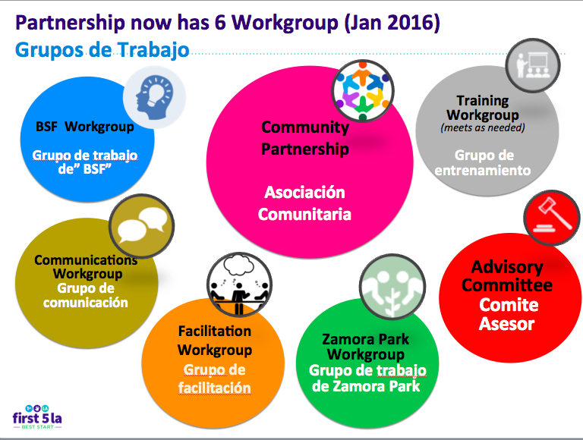

Group/Committee | Purpose | Staffed By:
BSF Workgroup | Established February 2016.  Support the implementation of the Building Stronger Families Grant | BSF Grantee  SPIRITT Family Services
Communications Workgroup | - Support community outreach  - Support the branding and promotion of Best Start SEM-EM  - Provides the first review of Community Sponsorship Applications.  - Up until 2016 it was implementing a “Best Start Businesses” initiative. | 2013-2017: First 5 LA  2017-2018: CSSP Capacity Builder
Facilitation Workgroup | Established January 2016.  - Design the agenda for the Community Partnership Meetings  - Facilitate the Community Partnership Meetings  - Identify and obtain raffle items for meetings. | CSSP Capacity Builder, but they also self-facilitate their own meetings.
Zamora Park Workgroup | Group meets to support the efforts to improve Zamora Park. Group meets adhoc, on an as-needed basis. No set membership or membership requirements.
Training Workgroup | Group meets to help identify training opportunities for the Partnership to utilize its Training and Technical Assistance (TTA) budget. | CSSP Capacity Builder

Gaps in the SEM-EM Bylaws: Questions to Answer

Below are remaining governance questions not answered by this document:

- How does the Advisory Committee fill a vacant Advisory Committee Seat? We have done special elections when needed, but it’s not officially in the bylaws.
- If an organizational representative leaves their position, does that organization keep their seat and replace the member with a new person? Or, is there another process? In practice, the organization has sent a new representative, but this isn’t officially in the bylaws.
- What is the process for regular review of the bylaws?
- What are the workgroups’ process for making decisions? This should be added to the bylaws.
- How do workgroups get created?

Developed 2012, Refined 2014

