- NAME of the resource / tool | Best Start Southeast LA Partnership Member Pledge Form
- WHAT is the purpose of the resource / tool? | This document is used to outline and confirm eligibility to become a voting Partnership member, and also gather demographic data regarding active members/meeting attendees.
- WHO developed the resource / tool? (If it was adapted from an existing document, please include a citation for the original source.) | This pledge form was developed for Best Start Southeast LA based on bylaws established via member discussion and formal approval processes.
- HOW should the resource / tool be used?  - What circumstances are ideal/appropriate?  - By whom and when?  - Is a particular skill set or special preparation needed? | These sample bylaws can used as a reference for explaining and confirming member eligibility requirements in a way that is easy to understand and community-friendly.
- WHY is this resource being recommended? (What makes is especially effective or useful for community-based work?) | Member requirements are usually outlines in bylaws, but can be difficult to explain or track using a lengthy, detailed document. This pledge form can help simplify the explanation of eligibility requirements and also serve as a tool for gathering important information about who is participating in meetings/activities. (Is the partnership engaging its target audience?)

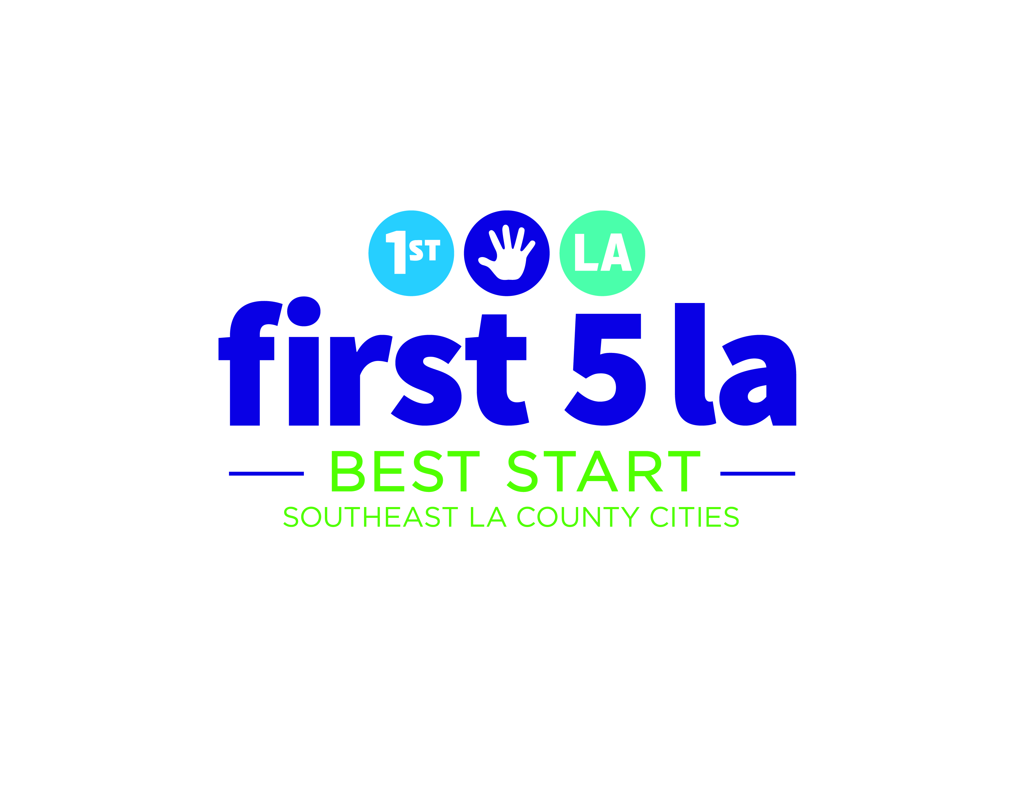
Community Partnership
Membership Pledge

“Community Partnership Members must live, work or volunteer in the Best Start Community.”
Check all the statements that apply to you.
- I live in the community.
- I work in the community.
- I volunteer in the community.
- I don’t live or work in this community. I understand I can participate but cannot vote.

“People can join the Best Start SELA Community Partnership after they have received an orientation.”

Check the statement that applies to you.
- I have atended a Best Start orientation.
- I have not atended an orientation but I will attend one before the next Community Partnership meeting.

1
2

“To vote members must have attended 5 Best Start SELA Community Partnership meetings in the last 7 months”

Please write down how many meetings you have attended.

Including today, I have attended _____ Best Start Community Partnership meetings.
- I can vote
- I cannot vote yet

3

“All members should identify which group they will represent at the meetings.”

Check the statement that applies to you.
- I am a parent of a child that is 0 a 5 yrs old
- I am a parent of a child that is 6 a 18 yrs old
- I am a community resident
- I represent an organization. Organization’s name: ________________________
4

“Para convertirse en un miembro tiene que cumplir con los requisitos de asistencia, hacer un compromiso formal, y ser un apasionado sobre Best Start.”

Please initial each statement:
____ I will attend a minimum of 80% of Community Partnership meetings (10 of 12 per year).
____ This pledge represents my formal committment to Best Start SELA.
____ I will be passionate about Best Start.

Signature: ___________________________________
Name: ___________________ Date: ______________

“All members should identify the community they belong to within the Best Start SELA boundaries.”

Check the option that applies to you.
- Bell
- Bell Gardens
- Commerce
- Cudahy
- Huntington Park
- Maywood
- Walnut Park
- Other: ________________

6
5

