- NAME of the resource / tool | Best Start Southeast LA Partnership Member Pledge Form
- WHAT is the purpose of the resource / tool? | This document is used to outline and confirm eligibility to become a voting Partnership member, and also gather demographic data regarding active members/meeting attendees.
- WHO developed the resource / tool? (If it was adapted from an existing document, please include a citation for the original source.) | This pledge form was developed for Best Start Southeast LA based on bylaws established via member discussion and formal approval processes.
- HOW should the resource / tool be used?  - What circumstances are ideal/appropriate?  - By whom and when?  - Is a particular skill set or special preparation needed? | These sample bylaws can used as a reference for explaining and confirming member eligibility requirements in a way that is easy to understand and community-friendly.
- WHY is this resource being recommended? (What makes is especially effective or useful for community-based work?) | Member requirements are usually outlines in bylaws, but can be difficult to explain or track using a lengthy, detailed document. This pledge form can help simplify the explanation of eligibility requirements and also serve as a tool for gathering important information about who is participating in meetings/activities. (Is the partnership engaging its target audience?)

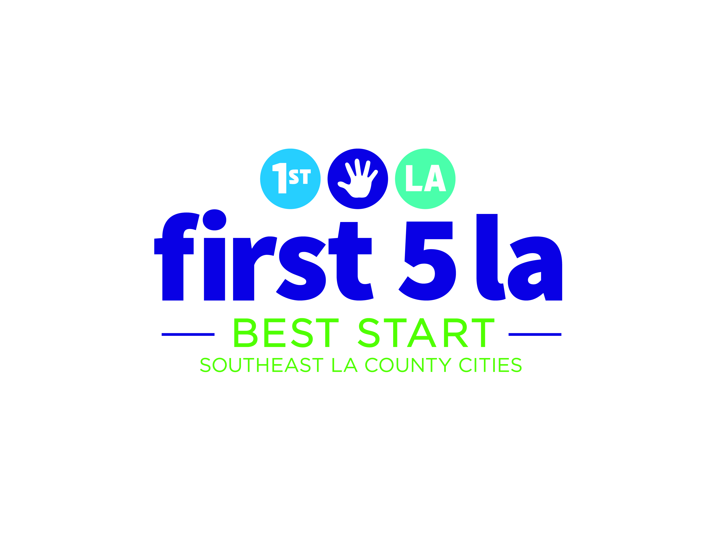
Promesa de Membresía de
la Asociación Comunitaria

“Los miembros de la Asociación Comunitaria deben vivir, trabajar o ser voluntarios en la comunidad de Best Start SELA.”

Marque todas las declaraciones que correspondan.
- Yo vivo en la comunidad.
- Yo trabajo en la comunidad.
- Yo soy voluntario en la comunidad.
- No vivo o trabajo en esta comunidad. Entiendo que puedo participar pero no puedo votar.

“Las personas pueden unirse a la Asociación Comunitaria de Best Start SELA después de que se hayan sido orientados.”

Marque la declaración que corresponda.
- Yo he asistido a una orientación.
- Yo no he asistido a una orientación, pero voy asistir a una antes de la próxima reunión de la Asociación Comunitaria.

2
1

3

“Para votar los miembros tienen que haber asistido a 5 reuniones de la Asociación Comunitaria de Best Start SELA en los últimos 7 meses”

Por favor escriba cuántas reuniones ha asistido.

Incluyendo hoy, he asistido a _____ reuniones de la Asociación Comunitaria Best Start.
- Puedo votar
- Todavía no

“Todos los miembros deben especificar a qué grupo representará durante las reuniones.”

Marque la declaración que corresponda.
- Soy padre de un niño en edad de 0 a 5
- Soy padre de un niño en edad de 6 a 18
- Soy residente de la comunidad
- Represento a una organización. Nombre de la organización: ________________________
4

“Para convertirse en un miembro tiene que cumplir con los requisitos de asistencia, hacer un compromiso formal, y ser un apasionado sobre Best Start.”

Por favor ponga sus iniciales antes de cada declaración:
____ Voy a asistir a un mínimo de 80% de las reuniones
de la Asociación Comunitaria (10 de 12 al año).
____ Esta promesa representa mi compromiso formal a Best Start SELA.
____ Voy a ser apasionado de Best Start.

Firma: _______________________________________
Nombre: _________________Fecha: ______________

“Todos los miembros deben especificar a que comunidad pertenecen dentro de los límites de Best Start SELA.”

Marque la opción que corresponda.
- Bell
- Bell Gardens
- Commerce
- Cudahy
- Huntington Park
- Maywood
- Walnut Park
- Otra: ________________

6
5

