- NAME of the resource / tool | Broadway Manchester Training and Learning Plan
- WHAT is the purpose of the resource / tool? | Formatted as a “worksheet”, this tool is meant to serve as a guide for community members when brainstorming their training/learning priorities based on available budgeted funds.
- WHO developed the resource / tool? (If it was adapted from an existing document, please include a citation for the original source.) | Capacity Builder Chrysta Wilson with input from BSBWM Community Partnership members.
- HOW should the resource / tool be used?  - What circumstances are ideal/appropriate?  - By whom and when?  - Is a particular skill set or special preparation needed? | It can be used to support a facilitated discussion where ideas shared by the group are documented and compiled into a summary training plan for review.
- WHY is this resource being recommended? (What makes is especially effective or useful for community-based work?) | Identifying learning / training priorities is an important first step toward organizing skill-building opportunities that are well aligned with group goals and priorities. Documenting recommendations also provides a record of group input and agreements, which supports focused follow up and minimized confusion about how decision were made.

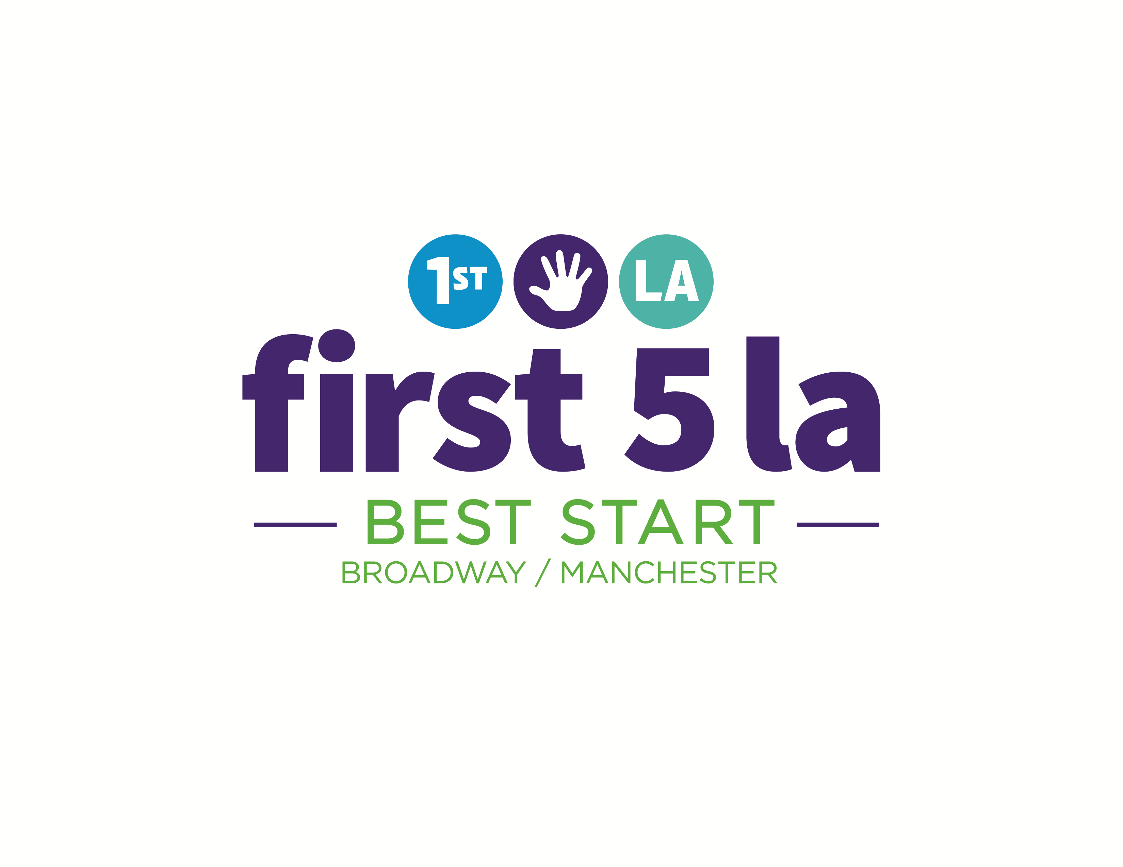

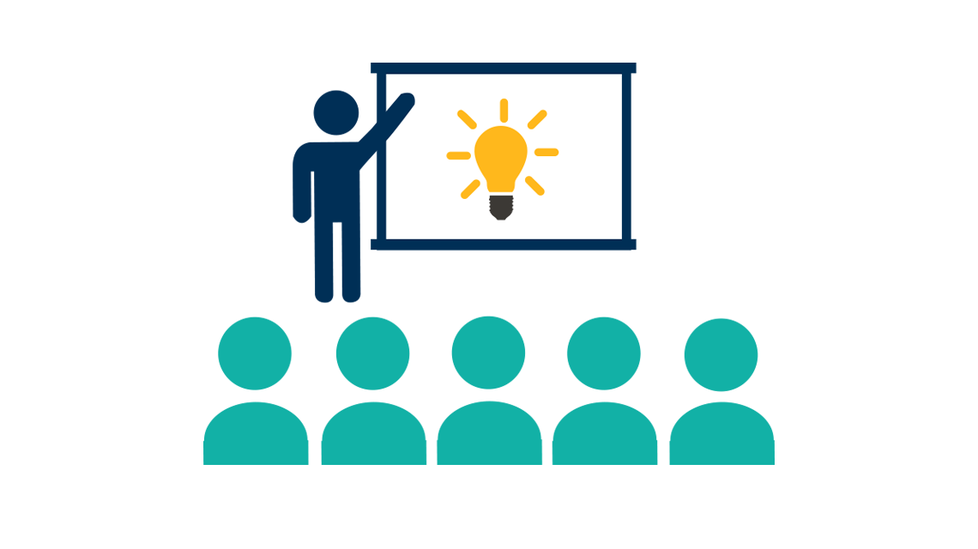

Partnership Training and Learning Plan

Draft: November 1, 2016

Vision/Goal For This Plan

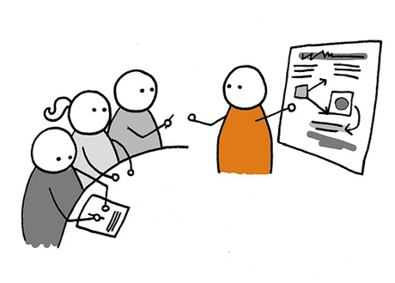
- Increase the skills of Community Partnership Members and Leadership Group Members.

- Provide learning and training opportunities for community members.

- Build leadership within the Community Partnership.

- Engage Partnership members.

When Do We Want To Accomplish This Goal?
- June 30th, 2017

What do we need to do?

- Understand How Much Money Is Available

- Broadway Manchester Community Partnership has $18,000 training budget to cover conferences, workshops, and trainings for active partnership members.

- Understand the rules and restrictions for the funds:

- Funds must be used by June 30th, 2017.

- Funds can be used to train Broadway-Manchester Community Partnership members.*
*A community member or community organization representative can become a partnership member by attending 1 community partnership meeting, according to the Partnership Bylaws.

- What is the process for funding trainings, workshops, and conferences out of this budget?
- The Leadership Group makes a request to use the training funds for a specific learning opportunity. The training request should be connected to the current work of the Partnership.

- The Leadership Group submits the request to Joaquin Calderon, Program Officers for Broadway-Manchester Best Start.

- Approval will be based on the relevance of the current work and availability of funds.

- What can the funds be used for?
- Conferences
- Workgroups
- Trainings

- How could these training and conference funds help the Partnership with its current goals? The training funds can:
- Build the skills of community partnership members.

- Build relationships with community agencies.

- Be used as a recruitment tool to bring in new members to the Partnership.

- Be used as a way to re-activate former members of the Community Partnership.

- What are our next steps?

  - We need to identify what we want to learn and what kinds of trainings would benefit the Partnership.

  - We need to identify the specific trainings, workshops, or conferences that we think would be beneficial.

  - We need to determine our process for choosing the training opportunities that get provided to the Partnership.

  - We need to determine our process for selecting training participants.

  - We need to decide how will we promote the training, workgroup, and conference opportunities to the Partnership?

- What training topics, conferences, or workshops do you think the Partnership would benefit from?
  - Train community partnership meetings on how to lead the Partnership.

  - Train Partnership members on public speaking norms for political and government forums.

  - To help Partnership members build skills, develop a Job Fair and/or a Community Resource and Information Fair.

  - ___________________________________________________

  - ___________________________________________________

  - ___________________________________________________

  - ____________________________________________________

- How would we know if our training plan was successful?

  - _______________________________________________________
  - ______________________________________________________

  - ______________________________________________________

  - ______________________________________________________

  - ______________________________________________________

  - _______________________________________________________

