- NAME of the resource / tool | Best Start South El Monte-El Monte (SEMEM) Advisory Committee Roles and Responsibilities
- WHAT is the purpose of the resource / tool? | The tool explains the history of why the Advisory Committee developed roles to begin self-managing their own meetings.
- WHO developed the resource / tool? (If it was adapted from an existing document, please include a citation for the original source.) | The tool was developed by Capacity Builder Chrysta Wilson after she facilitated several conversations with the Advisory Committee.
- HOW should the resource / tool be used?  - What circumstances are ideal/appropriate?  - By whom and when?  - Is a particular skill set or special preparation needed? | It can be used to illustrate the various roles required to facilitate a successful meeting.
- WHY is this resource being recommended? (What makes is especially effective or useful for community-based work?) | These facilitation/meeting manager roles may be useful for other community partnerships.

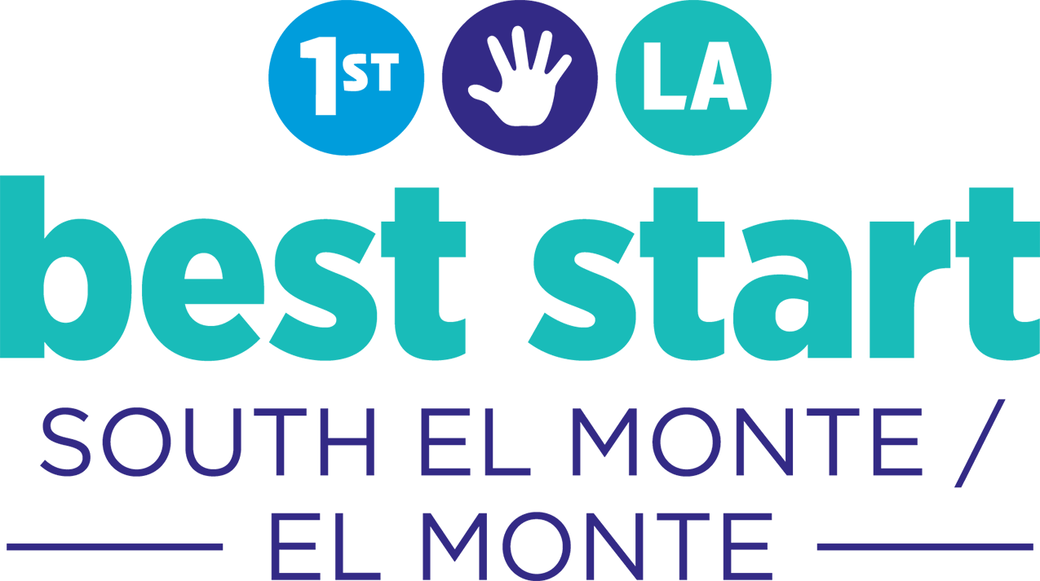

Advisory Committee Roles and Responsibilities

In August 2017, the Advisory Committee developed the following roles to help them take on more responsibility given the June 30th transition of the Capacity Builders.
In October 2018, the Advisory Committee developed the role and responsibility that will help them self manage and self-facilitate the Advisory Committee Meetings. They also decided that Advisory Committee members should volunteer to take on a role for 3 month commitment.
- Term #1: November 1, 2017 – January 31, 2018
- Term #2: February 1, 2018 – March 31, 2018
- Term #3: April 1,2018 – June 30, 2018.
- Term #4: July 1, 2018 – September 2018
- Term #5: October 2018-December 2018

Role | Volunteers | Sample Responsibilities
Agenda Development Team |  | Job Description: This is a two-member team.  - At the end of each Advisory Committee meeting, the Agenda Development Team facilitates a process to develop next month’s Advisory Committee Agenda.  - The Team meets again before the Community Partnership Meeting (4:30pm-5:00pm) to create the final digital agenda on the computer.  - In the past, this team has worked with the Capacity Builder to create the final agenda  - The team develops an icebreaker if time allows; they can also identify a volunteer to develop and lead an icebreaker activity.  - When making the agenda, the team identifies what materials are needed for each agenda item. They connect with others (e.g. the Program Officer, Workgroup members, or the Capacity Builder) to make sure items are prepared and available for the Advisory Committee Meeting.
Advisory Meeting Facilitator Team 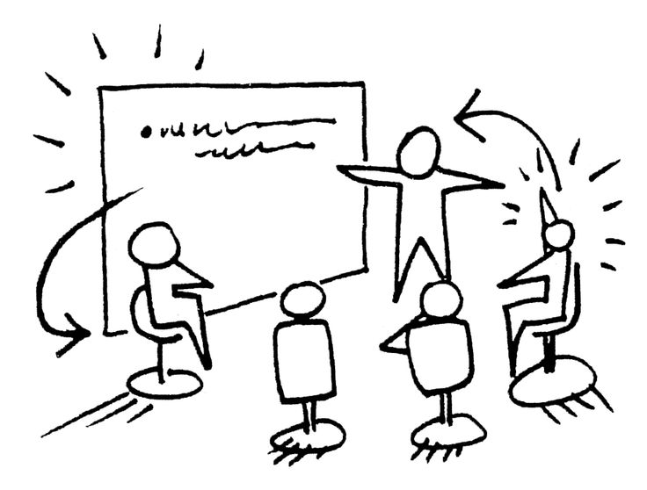 |  | Job Description:  This can be two people if needed.  - The Lead Facilitator(s) ensures that the meeting is starts on time.  - The Lead Facilitator(s) ensures that each agenda item is completed in it’s assigned timeframe.  - The Lead Facilitators manage the agenda, which means that they transition the group through each agenda item from the beginning to the end of the meeting.
Timekeeper |  | Job Description:  - The Timekeeper works with the Facilitation Team to start and end the meetings on time.  - The Timekeeper monitors the clock so that each agenda item doesn’t exceed its allotted time.
Vote Monitor |  | Job Description:  - If the Advisory Committee votes on something, The Vote Monitor ensures that we have quorum, e.g. that there is at least 1 more parent/resident representative than there is an organizational representative.  - When there is a vote, The Vote Monitor will say everyone’s name out loud to count the vote.  - The Vote Monitor repeats the vote so everyone knows what the result of the vote was.
Training Coordinator |  | Job Description:  - The Training Coordinator will be responsible for managing a list (or folder) with all of the training, conference, and workshop opportunities in it.  - The Training Coordinator will work with First 5 LA to get updates on how much money is remaining in the budget, and will share with the Advisory Committee.  - The Training Coordinator will ask members to share training, workshop, conferences opportunities at the Community Partnership meeting.  - Capacity Builder Note: **This job description needs to change because of the new LN structure
7. Greeter |  | Job Description:  - The Greeter will make sure that visitors and guests are welcomed and thanked for coming to the Advisory Committee meeting.  - When the visitor leaves, The Greeter also escorts them out of the meeting room.

