- NAME of the resource / tool | Step-By-Step Guide for Planning Community Partnership Meetings
- WHAT is the purpose of the resource / tool? | To develop and design meeting agendas.
- WHO developed the resource / tool? (If it was adapted from an existing document, please include a citation for the original source.) | Wilson and Associates developed this resource tool in 2008 based on San Kaner’s Communities at Work, in which it is referred to as “Topic, Result, Process”. It was then modified to include the agenda template for Best Start.
- HOW should the resource / tool be used?  - What circumstances are ideal/appropriate?  - By whom and when?  - Is a particular skill set or special preparation needed? | As a reference guide for community members who are involved in developing meeting agendas.
- WHY is this resource being recommended? (What makes is especially effective or useful for community-based work?) | It is a community-friendly guide for developing meeting agendas with clear, easy to follow steps.

A How-To Guide to Plan Community Partnership Meetings.

Step 1: Review the Partnership Meeting Timeframe
- Remind the Group that the Community Partnership Meetings take place from 5:00pm-7:30pm.

Step 2: Look at the Partnership Meeting Agenda Template (below)
- The template shows that certain parts of the meeting are already developed. For example:
    - We always start the meeting with a Welcome.
    - We always have updates at the meeting where we can hear from the different workgroups and committees, like:
      - The Communications Workgroup
      - The Advisory Committee
      - The Resident Outreach Coordinator
      - The Neighborhood Action Councils
      - First 5 LA

Step 3: What is the TOP?
T: TOPIC
O: OUTCOME
P: PROCESS

T: When developing the agenda, what are the topics that need to be on the agenda?

O: For each topic, what do we hope to accomplish by having that topic on the agenda? In other words, what is our “outcome” for the agenda item?

P: When looking at each agenda item, what is our process going to be? Will we have a large group discussion? Will we have small group discussion? Maybe we’ll play a game, or have a presentation. What will the process be?

Step 4: Plan the “Free Time” or unscheduled block of time in our agenda

We always have time on the agenda between 5:40pm-7:30pm. This is what we need to plan each month

Ideas:
- Speaker
- Presenter
- Training
- Activity
- Exercise
- Community Announcements
- Meeting Evaluation
- Thank you and Closing

Step 5: Identify roles for the meeting

Think about who will be the time-keeper, who will facilitate the ice-breaker, who will facilitate or present each item on the agenda, and lastly, who will be the “Lead Facilitator” that helps coordinate the meeting and make sure everyone has what they need so that the meeting is a success.

Roles:
- Lead Faciliator(s): Sometimes there are two
- Time Keeper: Keeps time and give time signals to the facilitator(s)/presenter(s)
- Agenda item facilitators: these are the people that are responsible for leading/facilitating/presenting each agenda item
- Icebreaker facilitator(s): Design(s) and facilitates the icebreaker.
- Raffle Facilitator(s): helps facilitate raffles at the meeting.

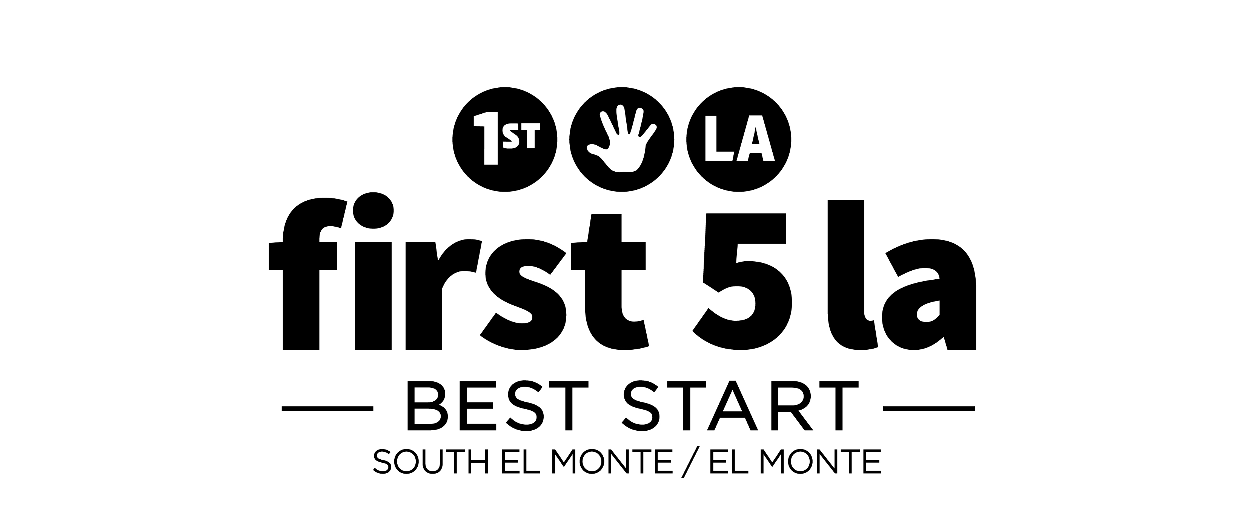

Best Start South El Monte-El Monte Community Partnership Meeting

Goals for Today’s Partnership Meeting

- Get to know other Community Partnership members
- Get updated on First 5 LA and Best Start activities
- Learn about community resources and meet community

partners

Meeting Agenda
Time | Agenda Item | Lead for the Agenda item
5:00pm -5:20pm  (20 mins) | Arrivals and Registration
5:20pm – 5:25pm  (5 mins) | Welcome And Agenda Review
5:25pm – 5:50pm  (25 mins) | First 5 LA and Best Start Updates  - Building Stronger Families (BSF)  - Communications Workgroup  - ROC/NAC  - Advisory Committee
5:50pm – 7:15pm  (85 minutes) | Free-Time/Unscheduled Time  ideas:  - Ice breaker  - Training  - Raffle  - Movement break/Exercise  - Presentation from a community organization  - Arts activity  - Other idea_____________________ | ,
7:15pm – 7:25pm  (10 min) | Community Announcements
7:25-7:30 | Meeting Evaluation and Closing

