- NAME of the resource / tool | 2016-2017 SEMEM Community Partnership Budget
- WHAT is the purpose of the resource / tool? | This budget overview is designed to help Partnership members understand what budgets they manage and track the use of funds as part of ongoing budget management.
- WHO developed the resource / tool? (If it was adapted from an existing document, please include a citation for the original source.) | Capacity Builder Chrysta Wilson developed the format and incorporated the input of Partnership members regarding budget content.
- HOW should the resource / tool be used?  - What circumstances are ideal/appropriate?  - By whom and when?  - Is a particular skill set or special preparation needed? | The form can be used to introduce budget structures or support regular budget monitoring as income and expenditures amounts are updated (preferably on a monthly basis).
- WHY is this resource being recommended? (What makes is especially effective or useful for community-based work?) | This budget overview format is simple and easy to understand based on feedback from community members.

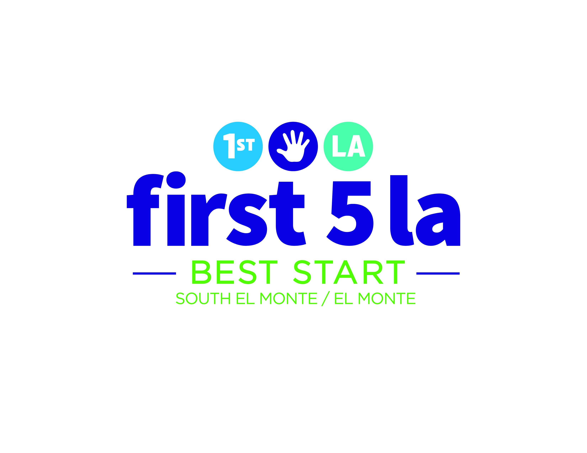

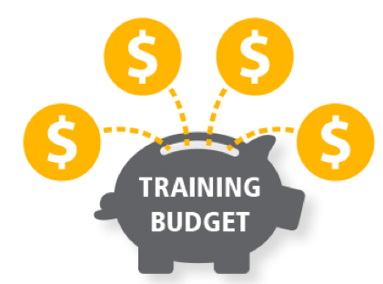
Community Partnership Budget
FY 2016-2017

Updated 2/14/2017

Training and Conference Budget: $30,000

Purpose: These funds are to build the skills of Community Partnership members so they can lead and support the work of the SEM-EM Community Partnership.

What can the funds be used for? Trainings, conferences, technical assistance, or workshops. Funds can also be used to bring a trainer or speaker to an existing community meeting, such as the monthly Community Partnership Meeting.

Timeframe: These funds are to be used between July 1, 2016 and June 30, 2017. All funds must be used by June 30, 2017.

Who Makes Decisions on this Budget: The Advisory Committee makes the final decision on how these funds are spent.

What were the funds used for? | Funds Spent  (July 1, 2016-June 30, 2017)
To send 1 person to Trauma-Informed Care Conference on September 23, 2016 | $125
To send 8 people to Families in Schools: 2016 Alliance Summit on October 20, 2016 | Estimated: $175 per person x 8 people + $400 transportation = $1,800
To send 5 people to Visión y Compromiso: 14th Annual Conference on October 27-29, 2016 | Estimated: $485
How much of the $18,000 budget do we have left? | How much of the funds have been spent as of 1/1/2017:
We have $27,590 remaining.  ($30,000 - $2,410 = $15,590) | $2,410

Communications and Marketing Budget: $50,000

Purpose: These funds can be used to increase awareness of Best Start South El Monte/El Monte and to support organizations and events in the South El Monte and El Monte communities that are connected to the Partnership’s vision for building stronger families and communities. These funds are a way to brand the South El Monte-El Monte Community Partnership.

What can the funds be used for? Sponsorship of community organizations and events. Applicants may apply for up to $2,000 per community event. Awardees are subject to a maximum community sponsorship funding level of $4,999 per fiscal year. They may also be used for promotional items, materials, or training for communications-related work of the South El Monte-El Monte Community Partnership.

Timeframe: These funds are to be used between July 1, 2016 and June 30, 2017. All funds must be used by June 30, 2017.

Who Makes Decisions on this Budget? The Communications Workgroup reviews all sponsorship requests and makes a preliminary approval. If approved, the Communications Workgroup presents a recommendation to the Advisory Committee. Finally, the Advisory Committee approves or declines the Sponsorship Request.
What were the funds used for? | Funds Spent
Business Engagement Posters – plastic cover | $660.85
1,000 Community Advocate Business Cards | $87.20
2016 SPIRITT Annual Gala | $1,500
2016 PALS Annual Conference | $2,000
Writing Workshop | $2,700
The Heart of Conflict Presentation | $250
Family Connections Photo Booth | $300
SGV Bike Campus Grand Opening | $2,000 (Pending AC Vote)
El Monte/South El Monte Chamber of C. Mixer | $250 (Estimated)
How much of the $25,000 Budget do we have left? | How much of the funds have been spent as of 1/1/2017:
We have $42,251.95 remaining.  ($50,000 - $7,748.05= remaining balance)  If we include the Bike SGV Sponsorship request, we have $15,251.95 remaining.  $25,000 - $9,748.05 = remaining balance including SGV Bike sponsorship | $7,748.05  (If we include the Bike SGV sponsorship request, then we have spent: $9,748.05)

Communications and Marketing Budget: $50,000
(page 2)

Possible Future Expenses:

- Emotional Abuse Calendar
- Printing of a newsletter with their stories
- Continuation of conflict resolution
- Marketing materials and collaterals related to the activity to enhance Zamora Park.

MEETING BUDGET: Average Small Meeting Costs

In December 2016, the SEM-EM Advisory Committee requested budget information on the specific expenses associated with each community meeting.

Current Meetings (6 total):
- Advisory Committee: 1 meeting per month, 2.5 hours.
- Communications Workgroup: 2 meetings per month, 2 hours each.
- Facilitation Workgroup: 1 meeting per month, 2 hours.
- Building Stronger Families Workgroup: 1 meeting per month, 2 hours.
- Community Partnership Meeting: 1 meeting per month, 2.5 hours. (Large meeting)
General Expenses for ONE SMALL Community Meeting | Average Cost  (These costs vary depending on the vendor, meeting size, and other factors.)
Transportation  Taxis. (Average $30 per round trip taxi ride)  Bus Tokens (average 4 tokens per person, at $1.75 each token = $7 per person) | $90  $28
Childcare  2 childcare providers, max 10 children | $210
Food and Beverage | $500
Interpreter  1 interpreter per 2 hour meeting | $350
Translation of meeting materials  Approximately 5 documents are translated per meeting | $350
Meeting Location  Meetings held at SPIRITT Family Services  Meetings held at the San Gabriel Valley Service Center | $275 per 3 hour meeting  $0: No fee
Photocopied Materials | These costs do not come out of the SEM-EM Community Budget.
Staff Support | These costs do not come out of the SEM-EM Community Budget.
Average cost for ONE SMALL Community Meeting. | $ 1,800
Average cost for 5 SMALL SEM-EM Community Meetings per month | $ 9,000

Our Budget Limitations:

Currently, the SEM-EM Community Partnership budget only allows for 6 meetings per month if we provide all of the supports (childcare, transportation, material translation, interpretation, food, and meeting location fees).

If we reduce the support provided to each meeting,
those savings can go to cover an additional meeting per month.

For example, the Advisory Committee could decide that we will provide light snacks versus full meals at the meetings, and that would save money that could be used to support an additional meeting each month.

