2018 SPONSORSHIP FORUM
Are you a Nonprofit Organization that is based in
Compton-East Compton or serves local families, and children 0-5?
We provide Community Sponsorship Funds to help support special events.

BEST START COMPTON-EAST COMPTON

Invites You to Attend
Free
R.S.V.P.
By Email: | cmontes@first5la.org
Phone: | (213) 482-7812
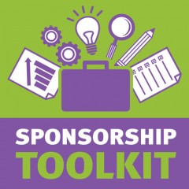
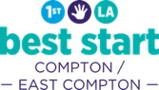
In this 2-hour Event you will learn:

WHAT is a Best Start Sponsorship

HOW to apply &

PROCESS from beginning to end
Registration Required
Email: | cmontes@first5la.org
Phone: | (213) 482-7812
Please RSVP to reserve your seat,
food, & childcare

Forum is FREE &. Lunch will be provided
WHEN: March 15, 2018
TIME: 12:00 PM – 2:00 PM
PLACE: Tower of Faith
4323 E Rosecrans Ave,
East Compton, CA 90221

