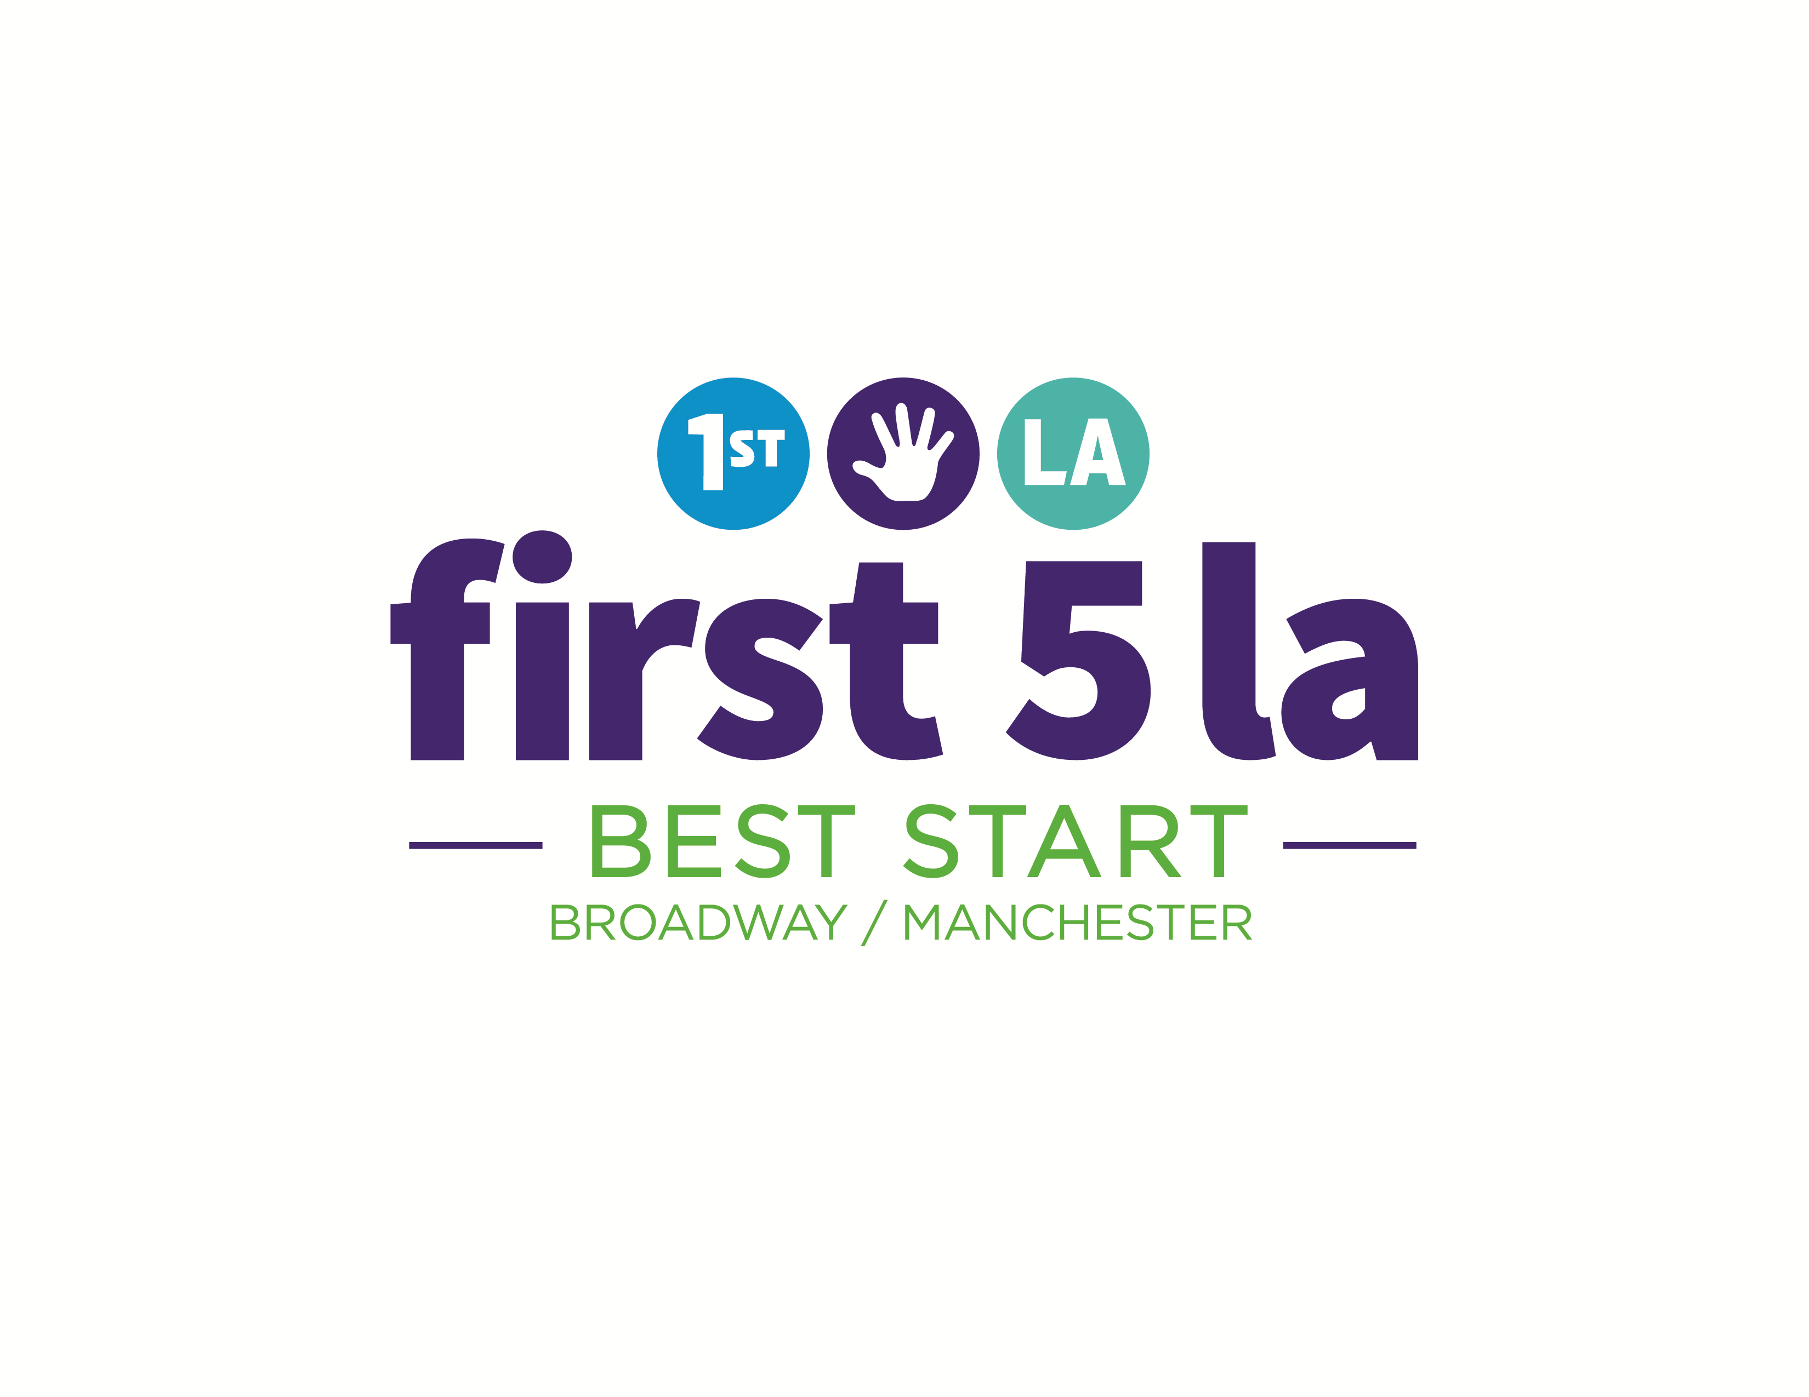

Outreach and Recruitment Plan

Draft: November 1, 2016

Vision/Goal For This Plan

Increase the number of people and community organizations participating in the Community Partnership meetings and Broadway Manchester Events.

When Do We Want To Accomplish This Goal?
June 30th, 2017

What Do We Need To Do?

- Decide who we are trying to recruit.

Ideas:
  - Men
  - African-Americans
  - Members from the community connections groups supported by the Resident Outreach Coordinators (ROCs) and NAC Organizer
  - Community Organizations
  - Young, single, and/or first time parents
  - People organized by the Building Stronger Families Grantees.
  - ________________________________________________

  - ________________________________________________

- What tools or resources do we need to do the recruitment?
Ideas:
  - Flyers
  - Brochures
  - Facebook
  - Emails
  - BroadwayManchester.org website

  - ________________________________________

  - ___________________________________________

- What support do we need?

Ideas:
  - Social Media Training
  - Communications support to manage social media accounts, like Facebook and the BroadwayManchester.org Website.

  - _______________________________________________________

  - _______________________________________________________

- What are some outreach activities that we can do to engage and recruit community members?

Ideas:
  - Using the sponsorship moneys managed by the Communications Workgroup

  - Using the training and conference budget to engage Partnership members.

  - Partner with Resident Outreach Coordinators (ROCs), Community Connection Groups, Neighborhood Action Council (NAC) organizer, and NACs to bring members to Partnership meetings and events.

  - Collaborate with community organizations and invite them to participate in Partnership Meetings and events.

  - Work with partners to recruit diverse community members to the Partnership.

  - Develop strategic community events to recruit participants and partners.

  - _______________________________________________________

  - _______________________________________________________

- How would we know if our outreach, engagement, and recruitment efforts were successful?

What might we see?

  - _______________________________________________________

  - _______________________________________________________

  - _______________________________________________________

  - _______________________________________________________

  - _______________________________________________________

  - _______________________________________________________

